# 

# A Project Report on

**“****Student Performance Analysis And Prediction System (SPAAPS)”**

**Master of Computer Applications-(AIML)**

**IN**



**Submitted By: Submitted To:**

* Rajat Kapoor (23MCI10069) Dr. Maajid Bashir
* Vimal Aagri (23MCI10016) Assistant Professor

1

# BONAFIDE CERTIFICATE

Certified that this project report, *Student Performance Analysis And Prediction System (SPAAPS)*,” is the bonafide work of **Rajat Kapoor and Vimal Aagri**, who carried out the project work under my/our supervision.

|  |  |
| --- | --- |
| Signature of the HOD | Signature of the Supervisor |
| **SIGNATURE** | **SIGNATURE** |
| Dr. Abdulla | Dr. Mazid  **SUPERVISER**  Academic designation |
| UIC/MCA | UIC/MCA |

Submitted for the project viva-voce examination held on

**Internal Examiner External Examine**

2

# DECLARATION BY THE CANDIDATE

I hereby declare that the project report entitled *“****Student Performance Analysis And Prediction System (SPAAPS****)”* submitted by our group to the Department of Computer Applications, University Institute of Computing, Chandigarh University, India, in partial fulfillment of the requirements for the award of the degree *“*Master of Computer Applications with Specialization in Artificial Intelligence & Machine Learning (MCA - AIML)*”* is a major project work carried out by us under the guidance of Dr. Maajid Bashir. We further declare that the work reported in this project has not been submitted and will not be submitted, either in part or in full, for the award of any other degree at this institute or any other university.

3

# ACKNOWLEDGEMENT

I take immense pleasure in thanking our H.O.D, Dr. Abdulla, for permitting us to carry out this minor project work. We wish to express our deep sense of gratitude to our guide, Dr. Maajid Bashir, for his valuable guidance and insightful suggestions, which greatly assisted us in completing this project on time. Words are inadequate to convey our appreciation for his encouragement and cooperation throughout this project. Finally, we would like to express our heartfelt thanks to our beloved parents for their blessings, and to our friends and classmates for their support and well-wishes, which were instrumental in the successful completion of this project.

4

# CERTIFICATE

This is certified that the project reported here

has been carried out partially by Under the guidance of

Associate Professor Dr. Maajid Bashir (E17490)

This is to certify that the project titled *“****Student Performance Analysis And Prediction System (SPAAPS)*** is the bonafide work of the students who successfully completed the certification course under my/our

guidance. This project demonstrates the application of YOLOv8 for real-time object detection in images, videos, and webcam feeds, developed with dedication and adherence to academic standards.

Dr. Abdulla Sir

(HEAD OF THE DEPARTMENT)

5

## ABSTRACT

The **Student Performance Prediction System** leverages advanced machine learning algorithms to automate the prediction of student performance based on various factors such as attendance, study hours, past grades, and other relevant features. This innovative solution addresses the challenges of manually assessing students' progress, enhancing accuracy, efficiency, and convenience for educators and institutions. By utilizing popular machine learning models, such as **Logistic Regression**, **Decision Trees**, and **Random Forest**, the system predicts students' future performance with high precision, helping identify students who may need additional support.

The system features a user-friendly interface, built with **Tkinter** or a web-based framework, which allows seamless input of student data and easy display of predictions. It provides detailed analysis and visualization of predicted outcomes, helping educators make informed decisions to improve student engagement and academic performance. Additionally, the system supports real-time updates and customization based on new data, making it adaptable to different educational environments and grading systems.

Overall, the **Student Performance Prediction System** offers a modern solution for improving educational outcomes by automating the prediction process, enabling early intervention, and fostering a more data-driven approach to teaching and learning.

### TABLE OF CONTENTS

* Bonafide certificate.....................................................2
* Declaration by the Candidate.....................................3
* Acknowledgement......................................................4
* Certificate…................................................................5
* Abstract.......................................................................6

**Table of Contents**

[1 Introduction 9](#_Toc57644)

[1.1 Background and problem motivation 9](#_Toc57645)

[1.2 Overall aim 9](#_Toc57646)

[1.3 Problem statement 10](#_Toc57647)

[1.4 Research Questions 11](#_Toc57648)

[1.5 Scope 11](#_Toc57649)

[1.6 Outline 12](#_Toc57650)

[1.7 Division of work 12](#_Toc57651)

[2 Theory 13](#_Toc57652)

[2.1 Machine Learning (ML) 13](#_Toc57653)

[2.1.1 Supervised vs Unsupervised ML 13](#_Toc57654)

[2.1.2 Transformers 14](#_Toc57655)

[2.1.3 Text Classification 14](#_Toc57656)

[2.1.4 Binary Text Classification 15](#_Toc57657)

[2.1.5 Artificial Neural Networks (ANN) 15](#_Toc57658)

[2.1.6 Support Vector Machine (SVM) 15](#_Toc57659)

[2.1.7 Random Forest (RF) 15](#_Toc57660)

[2.2 Related Surveys 16](#_Toc57661)

[2.2.1 Text Classification Using Machine Learning Methods - A Survey16](#_Toc57662)

[2.2.2 Text Classification Algorithms: A Survey 16](#_Toc57663)

[2.3 Related work 16](#_Toc57664)

[2.3.1 Student Performance Evaluation in Educational Data Mining 16](#_Toc57665)

[2.3.2 Using TensorFlow to Support Educational Problems 17](#_Toc57666)

[2.3.3 Tracking and Predicting Student Performance in Degree Programs 17](#_Toc57667)

[3 Methodology 18](#_Toc57668)

[3.1 Scientific method description 18](#_Toc57669)

[3.2 Project method description 20](#_Toc57670)

[3.3 Evaluation method 21](#_Toc57671)

[4 Choice of solution 22](#_Toc57672)

[4.1 Solution alternatives 22](#_Toc57673)

[4.1.1 Alternative 1 (TensorFlow with Keras) 24](#_Toc57674)

[4.1.2 Alternative 2 (MATLAB) 25](#_Toc57675)

[4.1.3 Alternative 3 (Amazon SageMaker) 25](#_Toc57676)

[4.1.4 Alternative 4 (RStudio) 25](#_Toc57677)

[4.2 Chosen solution (TensorFlow with Keras) 25](#_Toc57678)

[5 Implementation 26](#_Toc57679)

[5.1 Preparation 26](#_Toc57680)

[5.2 Preprocessing (TensorFlow) 28](#_Toc57681)

[5.3 Machine Learning (TensorFlow) 29](#_Toc57682)

[5.4 Prediction (TensorFlow) 30](#_Toc57683)

[5.5 Evaluation (TensorBoard) 32](#_Toc57684)

[5.6 Evaluation setup 32](#_Toc57685)

[6 Results 33](#_Toc57686)

[6.1 Resulting application/system 33](#_Toc57687)

[6.2 Measurement results 34](#_Toc57688)

[7 Discussion 37](#_Toc57689)

[7.1 Analysis and discussion of results 37](#_Toc57690)

[7.2 Project method discussion 38](#_Toc57691)

[7.3 Scientific discussion 39](#_Toc57692)

[7.4 Ethical and societal discussion 40](#_Toc57693)

[8 Conclusions 41](#_Toc57694)

[8.1 Future Work 42](#_Toc57695)

[8.1.1 The degrees of each course 42](#_Toc57696)

[8.1.2 Bigger dataset for SVM and ANN 42](#_Toc57697)

[8.1.3 Other types of algorithms 42](#_Toc57698)

**REFERENCE**………………………………………………………

**PLAGIARISM REPORT**…………………………………………………………..**52**

8

**1.Introduction To Project:**

The **Student Performance Analysis and Prediction System** is a comprehensive solution that applies advanced machine learning techniques to predict academic outcomes. This system is designed to accurately assess and forecast student performance, enabling educational institutions to identify students who may require additional support. By leveraging predictive models, the system provides insights into factors influencing academic success, making it ideal for applications in educational monitoring, targeted intervention, and curriculum improvement. Through high precision and data-driven analysis, this system offers reliable performance predictions, supporting student success across diverse learning environments.

**1.1. Problem:**

Before the introduction of advanced machine learning models, predicting student performance was a challenging task. Traditional methods relied heavily on manual analysis of student data, which was time-consuming, prone to biases, and required extensive human intervention. Additionally, predicting academic outcomes with accuracy and consistency was difficult, especially when working with diverse and dynamic datasets. Conventional approaches often fell short in providing timely insights, limiting the effectiveness of academic support strategies and interventions. The demand for a more efficient, accurate, and data-driven solution led to the development of this *Student Performance Analysis and Prediction System*, which leverages machine learning algorithms to provide reliable and timely predictions.

**1.2. Objective:**

The primary objective of the **Student Performance Analysis and Prediction System** is to automate the prediction and analysis of students’ academic performance based on historical data, enabling educational institutions to proactively support students' learning needs. The system is designed to provide educators with precise insights for improving student outcomes. Key objectives include:

1. **Predictive Analysis**: Accurately predicting future academic performance using previous test data, identifying areas where individual students may need additional support or improvement.
2. **Personalized Learning Recommendations**: Providing targeted insights that suggest which students require extra assistance, the subjects needing greater focus, and which areas might benefit from additional classes.
3. **Class-Level Insights**: Allowing educators to upload entire classes' data for batch analysis, enabling an overview of student performance trends and identifying groups of students who may need focused attention.
4. **Future Expansion**: Incorporating additional features, such as personalized e-book recommendations based on individual performance, attendance tracking and analysis, and real-time score updates, to help students stay on track toward their academic goals.
5. **Integration and Adaptability**: Ensuring easy integration with existing educational tools and formats, like CSV files, to make the system adaptable to various classroom needs and educational frameworks.

**1.3.Client Identification and Recognition of Need:**

The **Student Performance Analysis and Prediction System** is designed to support educational institutions, teachers, and academic administrators. By automating the process of predicting and analyzing student performance, the system offers several benefits:

1. **Enhanced Educational Support**: Assists teachers and administrators by identifying students needing extra help, allowing educators to tailor their support based on each student’s learning requirements.
2. **Improved Accuracy in Academic Insights**: Provides reliable predictions of future performance, minimizing human error and enabling data-driven decision-making to support students effectively.
3. **Class-Wide and Individual Analysis**: Processes data for entire classes or individual students instantly, helping educators make timely interventions that improve learning outcomes.
4. **Targeted Learning Interventions**: Offers insights to prevent academic setbacks by recommending specific subjects or areas where additional support, like tutoring or focused lessons, may benefit students.
5. **Adaptability and Ease of Integration**: The system can seamlessly integrate with existing educational tools, allowing data upload in CSV format and making it compatible with various institutional frameworks for efficient and versatile use.

**1.4. Scope:**

1. **Predictive Student Performance Analysis**: The system analyzes past test scores and academic data to predict students' future performance, making it suitable for educational applications focused on early intervention and academic support.

2. **Scalable and Flexible Integration: This** solution allows for the easy upload of student data in CSV format, enabling scalability and compatibility with various educational tools and institutional data systems.

3. **Comprehensive Academic Insights**: The system provides actionable insights on individual and class-wide performance trends, identifying areas needing improvement and guiding decision-making for targeted interventions, such as extra classes or tutoring support.

4.**Future Feature Expansion**: The project is designed for further development, with potential additions like personalized resource recommendations (e.g., e-books), attendance analysis.

**1.5 Limitation:**

* + 1. **Data Quality and Availability**: The accuracy of predictions relies on high-quality and comprehensive student data. Limited or incomplete data may reduce the system’s effectiveness, especially in schools with limited data collection infrastructure.
    2. **Initial Setup and Training Costs**: Implementing a student performance prediction system requires time and resources for data preparation, model training, and integration into existing systems, which may be challenging for schools with limited budgets.
    3. **Model Accuracy and Bias**: While predictive models can offer valuable insights, they may still be prone to biases, such as favoring specific student groups or academic trends. Regular model tuning and testing are essential to ensure fair and accurate predictions.
    4. **Data Privacy and Security**: Handling student data requires strict privacy and security protocols to comply with regulations and protect sensitive information, which can add complexity to the system’s deployment.
    5. **Computational Load for Large Datasets**: Analyzing and predicting for large datasets (e.g., entire school districts) may require substantial computational resources, potentially leading to delays or reduced performance if hardware is not equipped for high-volume data processing.

1. **RESEARCH METHODOLOGY:**

The research methodology for developing the Object Detection System using YOLO, OpenCV, Tkinter, and CVZone follows a systematic approach to ensure thorough design, implementation, and evaluation of the system.

**2.1Literature Review:**

## Research Questions

How is performance affected in terms of accuracy, precision, recall, f1 score, and prediction [5] when running the SVM vs ANN models on TensorFlow using student datasets from Ladok?

This main research question is broken down further into the following research questions:

1. Are ML algorithms an appropriate way and can they be used to find out these student patterns?
2. How to implement ML models (SVM and ANN) and what model performs best in terms of accuracy, precision, recall, and f1 score on an open-source ML framework using student data from higher education credit data?
3. How much data is needed to be able to draw these conclusions for classifying the dataset?

The scientific knowledge to be gained from the thesis will be threefold:

1. Determining the “appropriateness” or legitimacy of using ML algorithms for predicting student performance using only datasets from Ladok.
2. Seeing how SVM and ANN react under these certain conditions and to provide insights on improving ML model performance for this type of data.
3. Providing an objective method/view for determining the sufficiency of the size of the dataset.

# Theory

ML can be an overwhelming subject to tackle as it encompasses a large subset of research and studies on different algorithms for the purpose of solving complex tasks/patterns. This chapter will discuss several concepts and algorithms that will be useful to know as the reader moves forward.

## Machine Learning (ML)

ML is considered as a branch of Artificial intelligence (AI). It aims to imitate the way human beings solve problems in the form of creating computational neural networks that mimics neural networks in the brain

[7].

### Supervised vs Unsupervised ML

There are two forms of supervised learning in machine learning: classification and regression. An algorithm is used to properly allocate test results into specific groups, such as recognizing apples from oranges. Another supervised learning approach is regression, which employs an algorithm to identify the connection between dependent and independent variables. Linear regression, logistic regression, and polynomial regression are three prominent regression techniques.

Unsupervised learning uses machine learning methods to analyze and cluster unlabeled data sets. For tasks like grouping, association, and dimensionality reduction, unsupervised learning models are utilized. Clustering is a data mining technique for grouping unlabeled data by similarities and differences. The K number indicates the grouping's size and granularity. K-means clustering divides data into groups that are linked.

The difference is that in supervised learning, the algorithm learns from the training dataset by generating data predictions and correcting for the right answer repeatedly. While supervised learning models are more accurate than unsupervised learning models, data identification requires human involvement. Unsupervised learning models, on the other hand, discover the structure of unlabeled data on their own. Figure [1] is an illustration of ML classification [8].

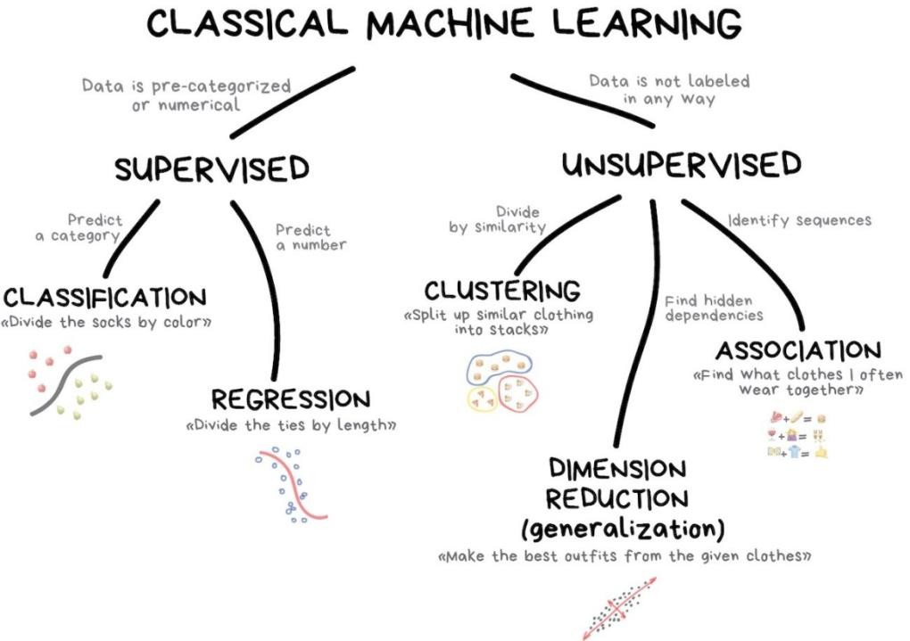

Figure [1]: showing an illustration of the difference between Supervised and Unsupervised ML. The figure is taken from a lecture slide on ML from the University of Chicago [9].

### Transformers

Transformer models use a developing collection of mathematical approaches known as attention or self-attention to discover subtle ways that even far-flung data pieces in a series impact and depend on one another. They're powering a surge of machine learning advancements termed "transformer AI" by some. Transformers are interpreting text and audio in real time, allowing hearing impaired people to join meetings and courses. They're assisting researchers in better understanding gene chains in DNA and amino acids in proteins, which can help speed up medication development. To avoid fraud, speed production, provide online suggestions, or enhance healthcare, transformers can recognize patterns and abnormalities. Every time someone searches on Google or Microsoft Bing, they utilize transformers [10].

### Text Classification

Text classification is the process of categorizing natural language texts and assigning tags to them within a specified set of categories. Apart from human classification, automated Classification APIs are also used to categorize significant sentences in a document so that important terms may be utilized [11].

### Binary Text Classification

Binary Text classification is a sub class of text classification and is a form of supervised learning technique which is used to predict whether a piece of text belongs to one of two categories. The datasets that are used to train this type of binary classifier is labelled [12].

### Artificial Neural Networks (ANN)

ANNs are also commonly known as just Neural Networks in ML make up the backbone of all ML programs. They can be seen as a composite function that’s made up by three components which are the neurons that perform the computation on the input data, the parameters which are the values that the ANN must learn the pattern of, and the biases which are the values that the ANN adds to the input data to construct a pattern [13].

### Support Vector Machine (SVM)

SVM is a supervised machine learning technique that may be used for both classification and regression (Supervised Learning). The goal of the SVM method is to discover a hyperplane in an N dimensional space that categorizes data points clearly. The hyperplane's size is determined by the number of inputs. If there are just two inputs, the hyperplane is merely a line. When there are three inputs, the hyperplane becomes a two-dimensional plane. When the number of inputs exceeds three, it becomes impossible to imagine [14].

### Random Forest (RF)

RF is a classification technique that is made from many decision trees, which are in turn data constructs that decide the rules/patterns from the input data. When creating each individual tree, it employs bagging (randomly sampling from the dataset) and input randomization to generate an uncorrelated forest of trees whose whole prediction is more accurate than any individual tree [15].

## Related Surveys

The following are two surveys on text classification methods in ML.

### Text Classification Using Machine Learning Methods - A Survey

Due to the high dimensional feature vector including noisy and irrelevant data, text categorization is a tough process. For removing unimportant features and lowering the dimension of the feature vector, many features reduction approaches have been developed. This article discusses how to classify text using machine learning algorithms and what features to look for [16].

### Text Classification Algorithms: A Survey

The number of complicated documents and texts has increased exponentially in recent years, necessitating a greater grasp of machine learning technologies to effectively identify texts in numerous applications. For researchers, finding appropriate structures, architectures, and methodologies for text categorization is a problem. Different text feature extractions, dimensionality reduction approaches, current algorithms and strategies, and assessment methods are all included in this review [].

## Related work

There are a multitude of ML research and development for predicting student performance. Below are some works that are like the one conducted in the thesis.

### Student Performance Evaluation in Educational Data Mining

The researchers created two machine learning models and compared their effectiveness in this study [18]. The first was a Random Forest (RF) model, while the second was an ANN model. TensorFlow was used as the backend for both. They aimed to use geography and evaluation data to predict student academic achievement. They did so by testing whether ANN can achieve state-of-the-art performance on a significant quantity of educational data, just as it does on data from other domains. In addition, comparing the performance of ANN with that of RF.

The motivation for this study was the growing interest among academics in using data mining to analyze student data. The authors of the report believed that these advancements in data mining should also aid the field of education. In the conclusion chapter, the authors stated that, for future work, Recurrent neural Networks (RNN) can be used for detecting students who are about withdraw or dropout. The authors said in the conclusion chapter that Recurrent neural Networks (RNN) can be utilized to detect students who are going to withdraw or dropout in the future. It is on this basis (research gap/ future work) that this paper will conduct this current research. In our thesis, it will differ in the type of ML algorithms that will be used (ANN vs SVM).

### Using TensorFlow to Support Educational Problems

The authors of this systematic study article [19] sought to show the outcomes of a systematic mapping procedure utilizing the TensorFlow framework on educational data mining projects. They also intended to help with explaining what kinds of problems to focus on, as well as identifying, demonstrating, and cataloging all academic publications that have covered it, as well as the methodologies used, such as neural networks and decision trees. The writers wanted to know how many papers were on this topic and where they came from. Also, to look at the difficulties that the TensorFlow framework has tackled in the realm of education. As well as determining existing techniques to solving these issues.

### Tracking and Predicting Student Performance in Degree Programs

There is a rich literature on predicting student performance using data driven approaches. However, there is a lack of research on predicting student performance relating to program completion (college programs, for example). New challenges are specified by this paper [20]. They are the following: the differentiation in student background and course selection, not all courses taken make an accurate student performance prediction, and lastly, the prediction must consider the students’ evolving progress.

**3.Requirement Analysis and Methodology:**

### 1. ****Functional Requirements****

#### ****Student Data Management:****

* **Student Information Storage**: The system must be able to store and manage student data such as name, ID, subjects, previous scores, attendance, and any other relevant attributes.
* **Data Entry/Import**: Users should be able to enter data manually through forms or import bulk data (CSV/Excel) for students.

#### ****Performance Prediction:****

* **Score Prediction**: The system should predict future performance (e.g., scores or grades) based on historical data like assignments, exams, and attendance using machine learning algorithms (e.g., regression models, decision trees).
* **Trend Analysis**: The system should be able to analyze trends in student performance over time and identify patterns that affect overall performance (e.g., low attendance leading to lower grades).

#### ****User Interface:****

* **Dashboard**: A user-friendly dashboard that displays student data, performance prediction, and trend graphs using a graphical interface (e.g., Tkinter or web-based).
* **Student Search and Filter**: Ability to search students by their ID, name, or filter by subjects, performance, etc.
* **Real-Time Feedback**: The system should provide real-time feedback on a student’s performance compared to their peers.

#### ****Reports and Data Export:****

* **Prediction Report**: The system must generate prediction reports showing projected future scores for each student.
* **Export Data**: Users should be able to export reports to CSV/Excel for further analysis or sharing with other stakeholders (e.g., teachers, parents).

#### ****Notifications:****

* **Alert System**: If a student's predicted performance is below a certain threshold, the system should send alerts to relevant stakeholders (e.g., teachers, parents).
* **Email Notifications**: Automated email alerts for significant changes in student performance or attendance (e.g., failing grades, missing assignments).

#### ****Student Insights:****

* **Strengths and Weaknesses**: The system should categorize students into strengths and weaknesses based on their grades, providing recommendations for improvement.
* **Subject Recommendations**: Based on historical data and predictions, the system should suggest subjects where the student may need extra attention or tutoring.

### 2. ****Non-Functional Requirements****

#### ****Performance:****

* **Real-Time Prediction**: The system should predict performance with minimal delay (e.g., under 3 seconds for a single student's prediction).
* **Scalability**: The system should be capable of handling a growing number of students and performance data without a significant decrease in performance.

#### ****Usability:****

* **Intuitive Interface**: The user interface (Tkinter or web) should be intuitive, making it easy for teachers, administrators, and parents to navigate and interpret the results.
* **Mobile Compatibility**: If the system is web-based, it should be responsive and accessible on mobile devices.

#### ****Reliability and Availability:****

* **High Availability**: The system should be available for continuous usage, with minimal downtime.
* **Error Handling**: The system should gracefully handle any unexpected inputs or errors in data without crashing.

#### ****Security:****

* **Data Privacy**: Student data must be protected and stored securely, ensuring that it complies with educational privacy regulations (e.g., FERPA).
* **User Authentication**: Teachers, administrators, and students should have role-based access with proper authentication mechanisms (e.g., login, passwords).

### 3. ****Technical Requirements****

#### ****Hardware:****

* **PC/Server**: The system should run efficiently on a standard PC or server, with moderate CPU and RAM specifications.
* **Cloud Hosting**: For scalability, the system can be deployed on a cloud platform (e.g., AWS, Google Cloud) to manage large datasets and user traffic.

#### ****Software:****

* **Python**: For backend development and machine learning implementation.
* **Machine Learning Libraries**: Scikit-learn, TensorFlow, or PyTorch for building and training the prediction model.
* **Data Manipulation**: Pandas and NumPy for data processing and analysis.
* **Visualization Libraries**: Matplotlib and Seaborn for graphing performance trends and predictions.
* **Web Framework**: Flask or Django for web-based interface development (if applicable).
* **GUI Libraries**: Tkinter (for desktop apps) or web technologies (HTML, CSS, JavaScript for web-based UI).

#### ****Integration:****

* **Email API**: Integration with an email service (e.g., SendGrid, SMTP) to send performance alerts and notifications.
* **Database**: Use an SQL or NoSQL database (e.g., MySQL, MongoDB) to store and retrieve student performance data.

**3.1 Technology or Tools used**:

**Programming Languages:**

1. **Python**:
   * **Role**: Primary language for back-end development.
   * **Usage**: Python is used for data processing, machine learning and deep learning model development, as well as for implementing algorithms to predict student performance based on historical data.

**Machine Learning & Deep Learning Libraries:**

1. **Scikit-learn**:
   * **Role**: Provides essential algorithms for machine learning, such as regression (for predicting scores), classification models (for performance categorization), and evaluation metrics (for model validation).
   * **Usage**: Used for building and training traditional machine learning models like Linear Regression, Decision Trees, Random Forests, etc.
2. **TensorFlow/PyTorch** (Deep Learning):
   * **Role**: For building advanced neural networks if required, such as predicting scores or categorizing students' performance using deep learning techniques.
   * **Usage**: TensorFlow or PyTorch would be used for training models on larger datasets and possibly for more complex prediction tasks such as time series analysis or classifying students based on their performance trends.
3. **Pandas**:
   * **Role**: Data manipulation and analysis.
   * **Usage**: Used for reading datasets (CSV, Excel), cleaning, and transforming data (handling missing values, encoding categorical data, etc.).
4. **NumPy**:
   * **Role**: Essential for numerical computing and array operations.
   * **Usage**: Used for handling large arrays and performing mathematical operations on the student data, such as calculating trends, averages, etc.
5. **Matplotlib/Seaborn**:
   * **Role**: Data visualization.
   * **Usage**: Used for generating visualizations like bar graphs, line charts, heatmaps, and histograms to visualize student performance, trends, and predictions.

**Web Framework:**

1. **Django**:
   * **Role**: Full-stack web framework for back-end development.
   * **Usage**: Django is used to build the web application, handle user authentication, manage student data, and serve machine learning models for prediction tasks. Django’s ORM (Object-Relational Mapping) can be used to interact with databases to store student data and performance predictions.
   * **Features**:
     + Admin dashboard for easy data entry and management.
     + REST API support using Django Rest Framework (DRF) for integrating with the front-end.
     + Authentication system for role-based access (teachers, students, admins).

**Frontend Development:**

1. **HTML**:
   * **Role**: Markup language for creating the structure of the web pages.
   * **Usage**: HTML is used to define the structure of web pages like dashboards, student data entry forms, and performance prediction results.
2. **CSS**:
   * **Role**: Styling and layout.
   * **Usage**: CSS is used to style the web pages, ensuring the interface is visually appealing and user-friendly. It can be used for customizing the design of student dashboards, graphs, and reports.
3. **JavaScript**:
   * **Role**: Client-side scripting language.
   * **Usage**: JavaScript is used to add interactivity to the web pages, such as real-time data updates, form validations, dynamic data visualization (using libraries like Chart.js), and creating an engaging user interface.
4. **Chart.js / D3.js** (JavaScript Libraries):
   * **Role**: Data visualization.
   * **Usage**: These libraries can be used to plot interactive charts and graphs for visualizing student performance, trends, and predictions on the front-end.

**Database:**

1. **PostgreSQL / MySQL**:
   * **Role**: Database for storing student data and prediction results.
   * **Usage**: The relational database stores structured data like student details, scores, attendance records, and prediction outcomes. Django's ORM allows seamless integration with databases.
2. **SQLite** (for smaller-scale development/testing):
   * **Role**: Lightweight database for initial development or smaller-scale applications.
   * **Usage**: Can be used as an initial database solution during development and testing phases.

**Deployment Tools:**

1. **Heroku / AWS**:
   * **Role**: Cloud platform for deploying the web application.
   * **Usage**: Platforms like Heroku or AWS can be used to deploy the Django application to the web, making it accessible for users to access real-time predictions and reports.
2. **Docker** (optional for containerization):
   * **Role**: Containerization for easier deployment and scalability.
   * **Usage**: Docker can be used to containerize the Django app and the machine learning model, ensuring that it runs consistently across different environments.

**Version Control:**

1. **Git/GitHub**:
   * **Role**: Version control system.
   * **Usage**: Used to track changes in the codebase, collaborate with team members, and maintain versions of the project through GitHub or GitLab repositories.

**Notification Systems:**

1. **Twilio/SendGrid**:
   * **Role**: For sending SMS/email notifications.
   * **Usage**: These services can be integrated to send alerts for low student performance or attendance issues.

**3.2 SWOT ANALYSIS:**

A SWOT analysis evaluates the strengths, weaknesses, opportunities, and threats associated with the object detection system. This analysis helps stakeholders understand the internal and external factors that may impact the system's development and implementation.

**SWOT Analysis for Student Performance Analysis and Prediction System**

**Strengths:**

* **Data-Driven Decision Making**: Leverages machine learning and deep learning models to predict student performance, allowing for evidence-based decisions and personalized interventions.
* **Automation**: Automates the process of predicting student performance, reducing manual effort and providing quicker insights for educators.
* **Scalability**: The system can easily be scaled to accommodate a large number of students, schools, or educational institutions.
* **Real-Time Prediction**: Enables real-time analysis of student data, allowing for timely interventions and support.
* **User-Friendly Interface**: Built using Django and integrated with front-end technologies like HTML, CSS, and JavaScript, providing an easy-to-use interface for teachers, students, and admins.

**Weaknesses:**

* **Data Dependency**: The accuracy of predictions relies on the quality and quantity of historical student data, and poor data quality can lead to inaccurate predictions.
* **Complexity in Implementation**: Integrating machine learning models into a working system can be complex and requires expertise in both data science and web development.
* **Initial Setup Costs**: While the software development itself might be cost-effective, setting up infrastructure, databases, and training models can incur significant initial costs.
* **Dependence on Accurate Data**: The system's predictions may become biased or flawed if data is incomplete or inaccurate, which could lead to incorrect interventions.

**Opportunities:**

* **Market Demand for Education Technology**: Growing demand for AI-driven solutions in education provides an opportunity for your project to be adopted by educational institutions, tutoring centers, and online learning platforms.
* **Integration with Other Educational Tools**: The system can be integrated with learning management systems (LMS), student information systems (SIS), and other educational platforms to create a more comprehensive learning ecosystem.
* **Personalized Learning**: As AI-based personalized learning becomes more popular, this system could be developed to offer tailored learning paths based on individual student needs.
* **Expansion into New Markets**: You could expand the system to include other prediction features like drop-out risk prediction, attendance prediction, or exam performance forecasting, making it versatile for various educational needs.

**Threats:**

* **Data Privacy and Security**: As the system collects sensitive student data, concerns about data privacy and adherence to regulations like GDPR could pose risks.
* **Resistance to Change**: Educational institutions and stakeholders might resist adopting new AI-driven tools, preferring traditional methods of assessment and performance tracking.

# Methodology

This method chapter describes the scientific/project method utilized for the thesis. It starts by listing the scientific questions and how they were approached and solved. Equations and an evaluation method are also presented.

## Scientific method description

This study used a quantitative method to approach and answer the research questions. The first research question in this study was to examine if ML algorithms are an appropriate way to, and if they can be used to find out student data patterns. As this research question is general, the approach to solve this goal was also general. This goal was be fulfilled by executing the main experiment in this study which was to clean the student data and then feed them into the different ML models in TensorFlow to generate some sort of pattern, whether it was Supervised (Classification vs Regression) or Unsupervised (Clustering vs Dimension Reduction vs Association). When a pattern was generated, then the research question was fulfilled.

The second research question in this study was to implement ML models (SVM and ANN) and to examine what model performed better in terms of accuracy, precision, recall, and f1 score on TensorFlow using datasets from Ladok. The approach to reach this research question was to define the parameters exactly to, measure and compare their values. In this case, Accuracy was defined as the fraction of predictions that an ML model got right [21]. Essentially:

𝑁𝑢𝑚𝑏𝑒𝑟 𝑜𝑓𝑐𝑜𝑟𝑟𝑒𝑐𝑡 𝑝𝑟𝑒𝑑𝑖𝑐𝑡𝑖𝑜𝑛𝑠

𝐴𝑐𝑐𝑢𝑟𝑎𝑐𝑦 =

𝑇𝑜𝑡𝑎𝑙 𝑛𝑢𝑚𝑏𝑒𝑟 𝑜𝑓 𝑝𝑟𝑒𝑑𝑖𝑐𝑡𝑖𝑜𝑛𝑠

𝑂𝑅

𝑇𝑃 + 𝑇𝑁

𝐴𝑐𝑐𝑢𝑟𝑎𝑐𝑦 =

𝑇𝑃 + 𝑇𝑁 + 𝐹𝑃 + 𝐹𝑁

𝑊ℎ𝑒𝑟𝑒:

𝑇𝑃 = 𝑇𝑟𝑢𝑒 𝑃𝑜𝑠𝑖𝑡𝑖𝑣𝑒, 𝑇𝑁 = 𝑇𝑟𝑢𝑒 𝑁𝑒𝑔𝑎𝑡𝑖𝑣𝑒,

𝐹𝑃 = 𝐹𝑎𝑙𝑠𝑒 𝑃𝑜𝑠𝑖𝑡𝑖𝑣𝑒,𝐹𝑁 = 𝐹𝑎𝑙𝑠𝑒 𝑁𝑒𝑔𝑎𝑡𝑖𝑣𝑒

Were as Precision and Recall were defined as the proportion of positive identifications and the proportion of actual positives respectively [22].

𝑇𝑃 𝑇𝑃

𝑃𝑟𝑒𝑐𝑖𝑠𝑖𝑜𝑛 = , 𝑅𝑒𝑐𝑎𝑙𝑙 =

𝑇𝑃 + 𝐹𝑃 𝑇𝑃 + 𝐹𝑁

F1 Score was defined as the combination of Precision and Recall [23] into a single measurement that accounts for both, as neither alone provide the complete tale of how an algorithm performs.

(2 ∗ 𝑃𝑟𝑒𝑐𝑖𝑠𝑖𝑜𝑛 ∗ 𝑅𝑒𝑐𝑎𝑙𝑙)

𝐹1 𝑆𝑐𝑜𝑟𝑒 =

𝑃𝑟𝑒𝑐𝑖𝑠𝑖𝑜𝑛 + 𝑅𝑒𝑐𝑎𝑙𝑙

The third research question in this study was to discern how much data was needed [24] to be able draw these conclusions (who needed help and who didn’t) for classifying the datasets. This study used

1. **Project Method Description:**

This study consisted of five phases in total. The first phase consisted of a literature study. The study looked at previous related work in the form of research articles, surveys, journals, and e books. This process was done to familiarize the reader on the current state-of-the-art and to show a research gap, to justify the current research that was being conducted. Google Scholar was used to find these resources.

The second phase consisted of designing and planning the experiment. The student dataset received from faculty senior lecturer Stefan Forsström at Mid Sweden University was analyzed and consider for different cleaning methods to prepare for ML training. Afterwards, the study considered different frameworks to train and compare the ML algorithms. Furthermore, different “scoring” methods were considered to evaluate the trained ML models.

The third phase (Implementation) was closely related to the second phase. This was where the execution of the plan and most of the hard work was conducted. It consisted of cleaning the student dataset using Excel, learning, and training the ML models using the dataset in TensorFlow, scoring the models by applying different metric measuring functions, and finally evaluating the models by generating metric values and graphs.

The fourth phase consisted of scoring, plotting, and comparing the generated data. This was the process of organizing and presenting the results of the generated scores from the ML models. Scoring, often known as prediction, is the act of creating values from new input data using a trained machine learning model. The created values or scores can be used to predict future values, but they can also be used to represent a predicted category or event. The score's meaning is determined by the type of data that is submitted and the model that is built. [25]

The fifth and final phase consisted of analyzing the results from the measured data. Since the TensorFlow framework was used, there were plenty of tools and articles on analyzing data. Different analyzing tools and approaches were considered to analyze the trained models and some tools were chosen to visualize the model in the form of diagrams and charts.

**Phase 1: Literature Study**

* **Objective**: To familiarize the reader with the current state-of-the-art in student performance prediction and machine learning (ML) applications in education.
* **Activities**:
  + Conduct a thorough literature review to explore previous work on student performance prediction models, surveys, research papers, and books.
  + Identify existing gaps in research or areas that require further exploration.
  + Use platforms like Google Scholar to find relevant research articles and journals to gather insights.
  + Focus on how machine learning models (e.g., decision trees, neural networks, regression models) have been used to predict student performance.
  + Identify existing challenges, such as data quality, feature selection, and model accuracy.

**Phase 2: Designing and Planning the Experiment**

* **Objective**: To prepare and plan the framework, dataset, and evaluation metrics for training the ML models.
* **Activities**:
  + **Data Collection**: Obtain the student dataset, which could be sourced from schools, universities, or public datasets like those from Kaggle or the UCI Machine Learning Repository.
  + **Data Preprocessing**:
    - Clean the dataset using techniques such as handling missing data, outliers, and normalizing numerical features.
    - Perform feature selection to identify the most significant factors (e.g., attendance, previous grades, study habits) influencing student performance.
  + **Framework Selection**:
    - Decide on ML frameworks such as **Scikit-learn**, **TensorFlow**, or **XGBoost** for training the models.
    - Choose algorithms that best suit the task, such as regression for continuous outcomes (e.g., final grade prediction) or classification for categorical outcomes (e.g., pass/fail prediction).
  + **Evaluation Metrics**:
    - Consider different metrics like **accuracy**, **precision**, **recall**, **F1-score**, and **confusion matrix** to evaluate the model's performance.
    - Decide if cross-validation is needed for model evaluation.

**Phase 3: Implementation**

* **Objective**: To implement the planned methods and execute the ML training, evaluation, and testing.
* **Activities**:
  + **Data Cleaning**: Use Python (Pandas, NumPy) to clean and preprocess the dataset, including handling missing values and encoding categorical features.
  + **Model Training**:
    - Train different machine learning models (e.g., decision tree, random forest, SVM, neural networks).
    - Fine-tune hyperparameters and apply techniques like grid search or random search to optimize model performance.
  + **Model Evaluation**:
    - Evaluate the models using the chosen metrics from Phase 2 (e.g., accuracy, precision, recall).
    - Use training/validation/test splits or cross-validation to assess model robustness and generalizability.

**Phase 4: Scoring, Plotting, and Comparing Results**

* **Objective**: To generate predictions, present results, and compare the performance of different models.
* **Activities**:
  + **Prediction**: Use the trained models to predict student performance on new or unseen data.
  + **Scoring**: Assess how well each model predicts the outcome using the evaluation metrics. Create visual representations like bar charts, confusion matrices, and ROC curves to assess classification models.
  + **Model Comparison**: Compare the performance of different models using the generated scores, and choose the best-performing model.
  + **Visualization**: Use libraries like **Matplotlib**, **Seaborn**, or **Plotly** to create charts and plots to visualize model performance.

**Phase 5: Analyzing the Results**

* **Objective**: To analyze the model results and draw conclusions from the performance predictions.
* **Activities**:
  + **Analysis**: Review the metrics from the trained models and interpret the findings.
    - Identify patterns or trends in the data (e.g., which features most impact student performance).
    - Understand how well the model generalizes to new data.
  + **Visualization**: Use tools like **TensorBoard** (if using TensorFlow) or other visualization tools to analyze and present the performance of the models.
  + **Refinement**: Based on the analysis, identify areas of improvement and refine the model if necessary.
  + **Conclusion**: Draw conclusions about the factors influencing student performance and how the prediction model can be used to assist teachers and administrators in making data-driven decisions.

# Choice of solution

In this study TensorFlow was decide on to be used as the platform for training and evaluating the ML algorithms. Keras is an inbuilt framework of ML APIs in TensorFlow and was used to facilitate the implementation of the study.

## Solution alternatives

When approaching this thesis, the way to think about it was to consider the 7 stages of ML, as framework of reference in figure [2]. The 1st stage is the problem definition which had a straightforward albeit rough solution which is to sit down and specify a scientific problem with measurable parameters to test later and to find a scientific justification for conducting the study as well as a practical benefit that the study would provide.

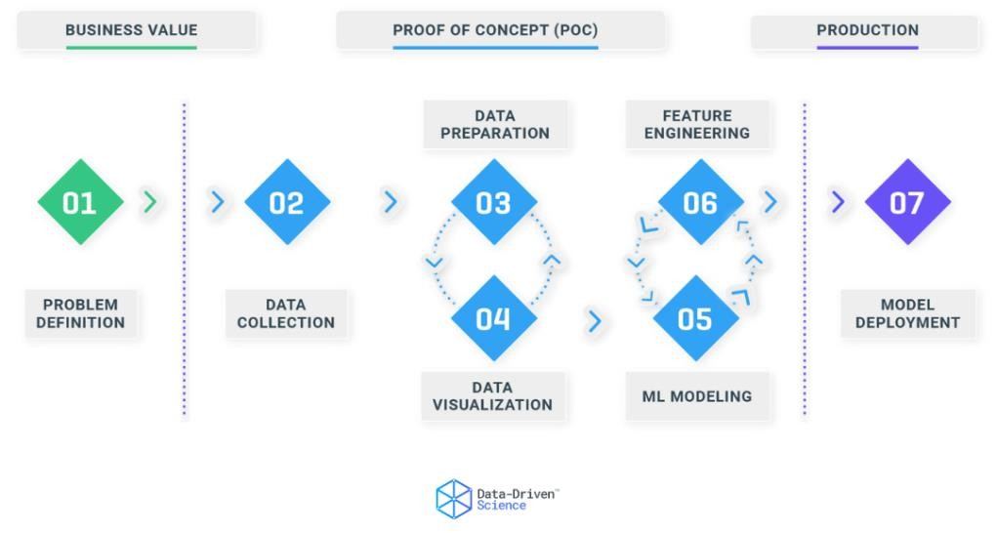

### Alternative 0 (Basic Approach Machine Learning Regression)

RStudio was the final framework considered and is an integrated development environment for the programming language R which provides statistical computing and graphics. It has two formats: a desktop application version (RStudio Desktop) and a web-based application version (RStudio Server). Both versions are open-source and provide free versions of the applications.

### Alternative 1 (TensorFlow with Keras)

Among the frameworks that were considered for this thesis, the one that was chosen was TensorFlow due to ease of use as it was a cloud-based ML computing platform built and supported by Google Inc.

Keras is a Google developed high level deep learning API for creating neural networks. It is simple to understand and use since it gives a highlevel python frontend with the flexibility of different backends for computation. Keras is slower than other deep learning frameworks because of this, yet it is incredibly user friendly.

### Alternative 2 (MATLAB)

Another framework that was considered was MATLAB as it is also widely used for ML applications. It includes interactive tools that make connecting to and importing data, as well as other ML operations, simple. Inbuilt functions are used for identifying, deleting, and cleaning data for data analysis.

### Alternative 3 (Amazon SageMaker)

The third framework was Amazon SageMaker, developed by Amazon, which comes with hosted Jupyter notebooks to visualize and analyze training data. It provides tools to create, train, and deploy ML models for predictive analytics.

### Alternative 4 (RStudio)

RStudio was the final framework considered and is an integrated development environment for the programming language R which provides statistical computing and graphics. It has two formats: a desktop application version (RStudio Desktop) and a web-based application version (RStudio Server). Both versions are open-source and provide free versions of the applications.

## Chosen solution (Basic Approach machine Learning)

For this thesis, TensorFlow was chosen as the framework for the task. Among the reasons that it was chosen, was that it is open source which led to a lot of traction and the adoption of a huge community. It has great architectural support, making it simple to deploy computing across a spread of platforms, including PCs, server clusters, mobile devices, and edge devices. When ML frameworks are pitted against one another, TensorFlow nearly always wins. The prominence of community collaboration on the web are mostly responsible for the plethora of resources and help online.

# Implementation

The implementation of the thesis was segmented into five main stages, shown in figure [4], each segment had its own set of challenges such as figuring out the right format, debugging etc., and their own set of solution such as finding the right code snippet, understanding how to use data frames, what type of data could be used in the framework, etc. All these challenges will be discussed further below in the subchapters.

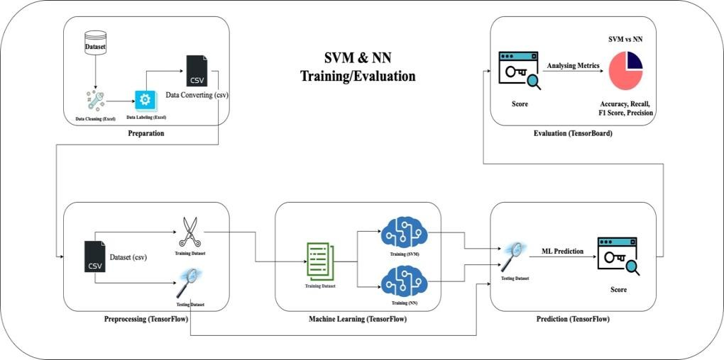

Figure [4]: Showing an overview image of the thesis implementation. The process was segmented into five different stages with their own set of unique challenges and solutions. More details were discussed further below.

## Preparation

The implementation began by fetching anonymous student datasets from Ladok by Stefan Pettersson seen in figure [5]. These data had been previously looked at by Pettersson and were what gave rise to the initial idea for the thesis. As they were unorganized and messy, they were also quite difficult to get started working with, due to not know exactly what they represented

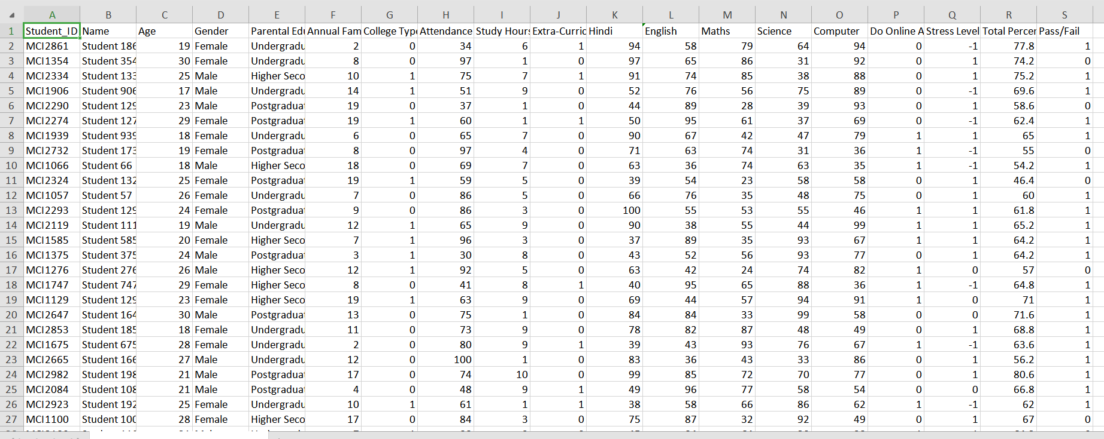

Figure [5]: A snippet from the initial data that was received from Stefan Pettersson.

Further meetings were had with Stefan Forsström, and new datasets were fetched from Ladok that had the premise of (given these input data (course results), what are the chances that the student would clear this target data (target course). The dataset was then rewritten and organized into a single page instead of having multiple separate pages in the Excel file. There was some excess information such as scope, course code, and period seen figure [6]. These were disposed of.

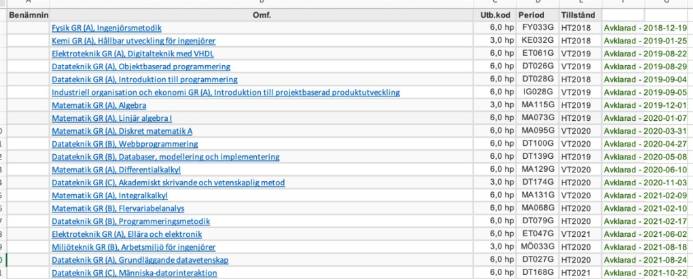

Figure [6]: A slice of the final data that was fetched from Ladok.

The data was then converted into binary information. (1s and 0s) instead of text information. This was the process of Data Labeling in Excel. Furthermore, they were converted into a Comma Separated Value (CSV) file through Excel, seen in figure [7], to be uploaded later into the TensorFlow framework.

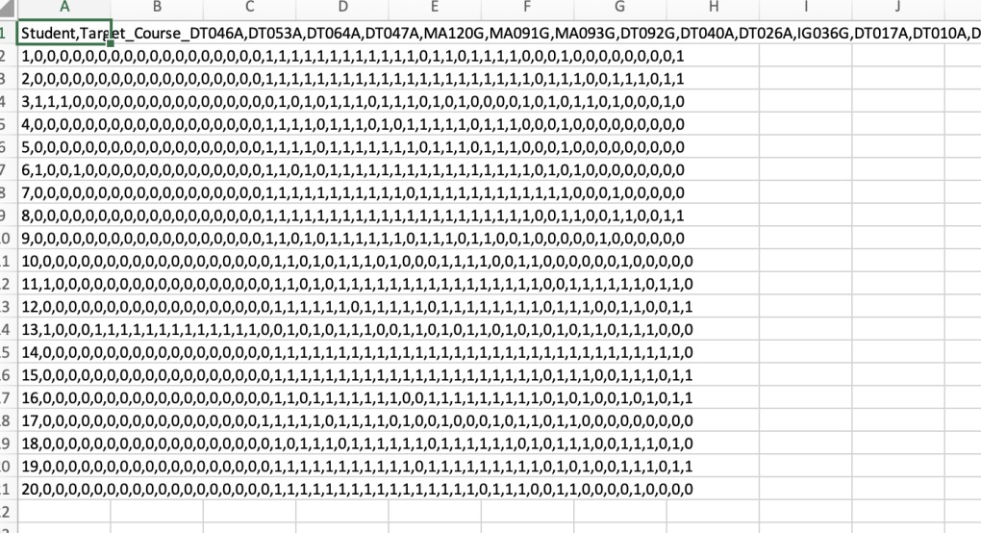

Figure [7]: The CSV version of the binary dataset.

## Preprocessing

With the CSV file ready, it was then uploaded to TensorFlow through

Google Colab platform, and it was run on a high-performance GPU on Google Cloud which provided a free tier version of Colab and provided about 12 GB of RAM and with limited access to high memory VMs which have 25 GB RAM. The dataset was split into two separate datasets, one for training the ML algorithms (Training Dataset) and one for testing the ML algorithms (Testing datasets). These datasets were held in a so called “dataframe”, seen in figure [8], which is a datatype object created and stored in TensorFlow. That concluded the Preprocessing phase.

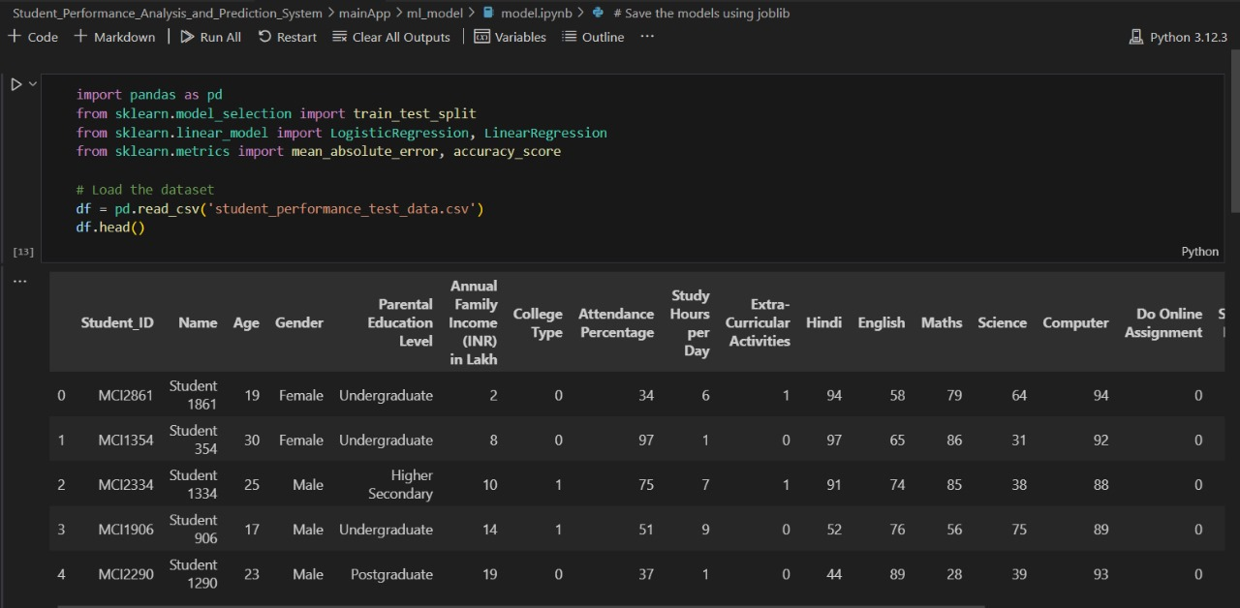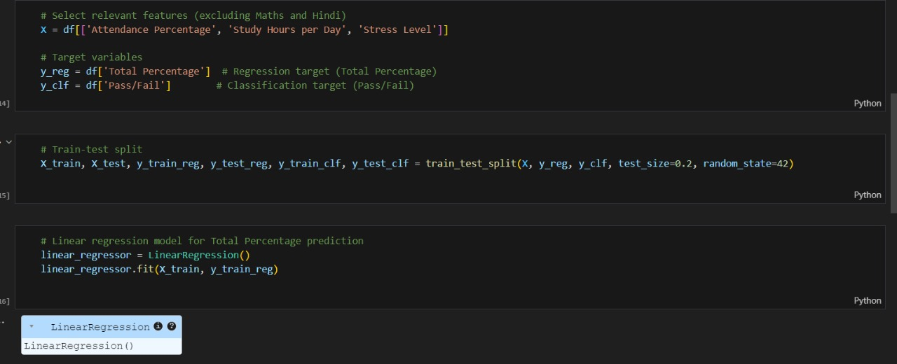

Figure [8]: The CSV dataset turned to a dataframe object in TensorFlow.

## Machine Learning

The SVM and ANN models were built using Keras API. The process was made easier due to Keras having prebuilt models and layers that were utilized to add the layers to the models, compile the models, fit the model which means to run the model and created a datatype called “history”. The training dataset was inputted into the SVM and ANN models respectively as the fitting process was run, seen in figure [9] and [10]. Furthermore, in this phase, different metrics were added such as Accuracy, Precision, Recall, and F1 Score.

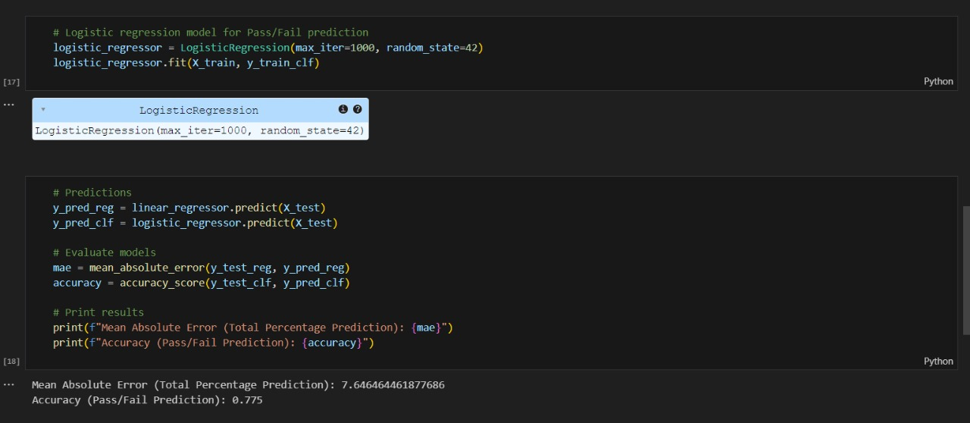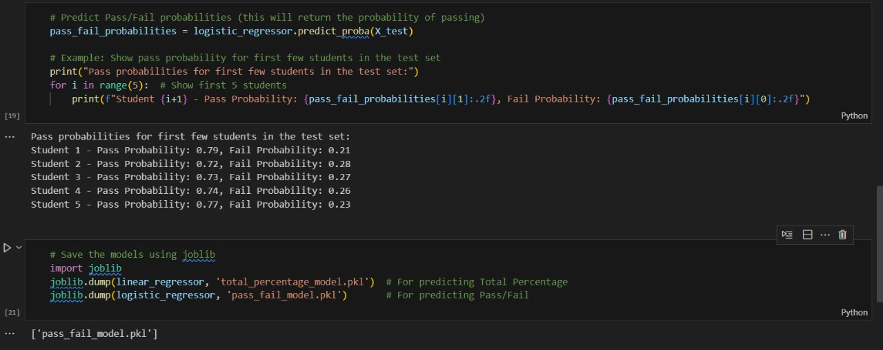

## Prediction

The trained SVM and ANN model were then forced to make a prediction on the testing dataset and generated a value between 0% and 100%, seen in figure [11] and [12] that indicated how likely the outcome would be a success “1”.

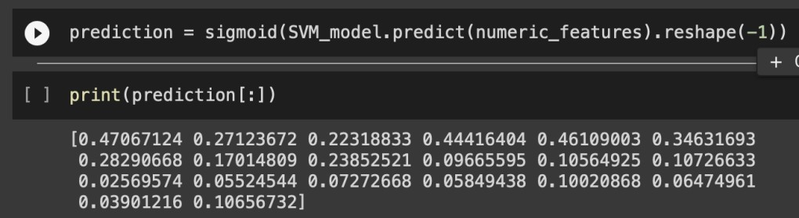

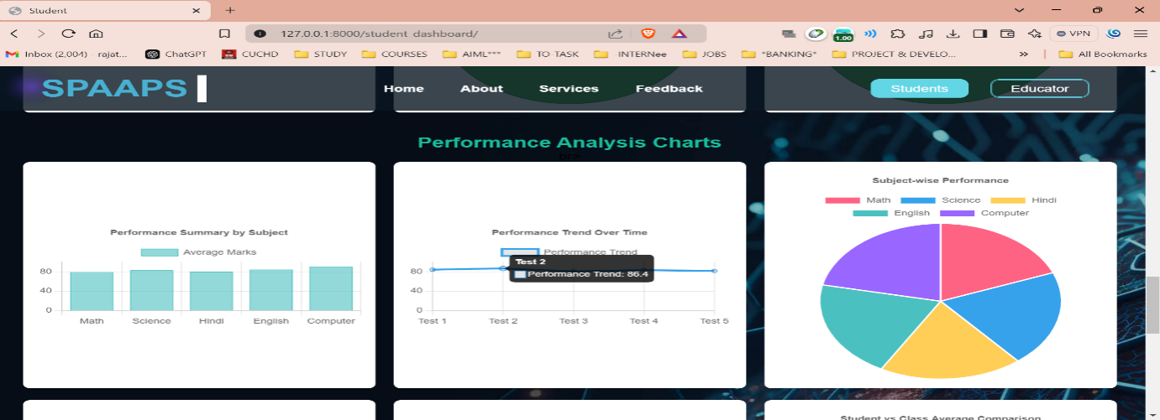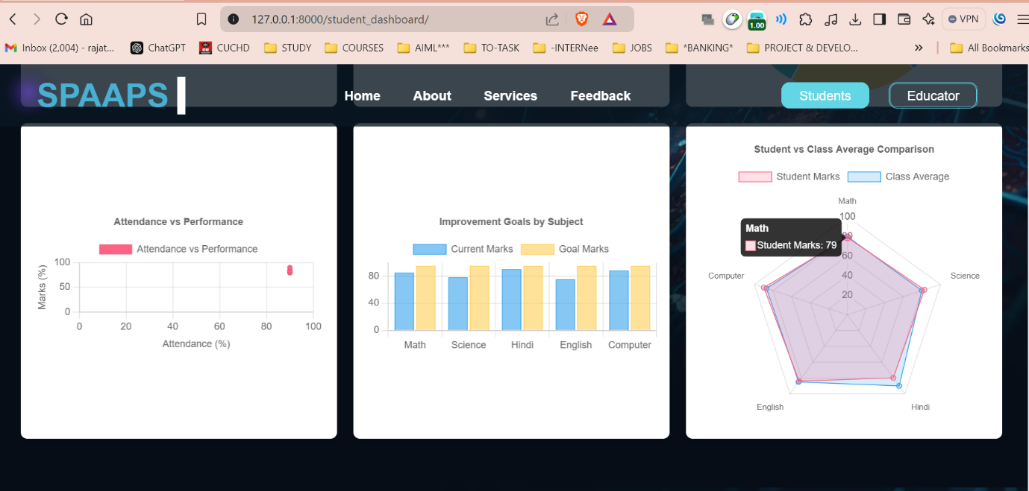

## Evaluation

The overall value of metrics (Recall, Precision, F1 Score, and Accuracy) of both SVM and ANN models were then fetched using the Sklearn API which provides complete functions to measure the mentioned metrics. These metrics were then plotted and compared against each other using TensorBoard which is a platform that provides the measurements and visualizations required.

## Evaluation setup

This study compared two different ML algorithms (SVM vs ANN) to see which one performed the best in terms of Accuracy, Precision, F1 Score and Recall. The tools that were used to measure and evaluated the performance of these algorithms were a mixture of APIs for building and training the models (Keras), a library of tools for statistical analysis and metric measurement (scikit learn), and tools for providing graphical measurement and visualization of the results (TensorBoard).

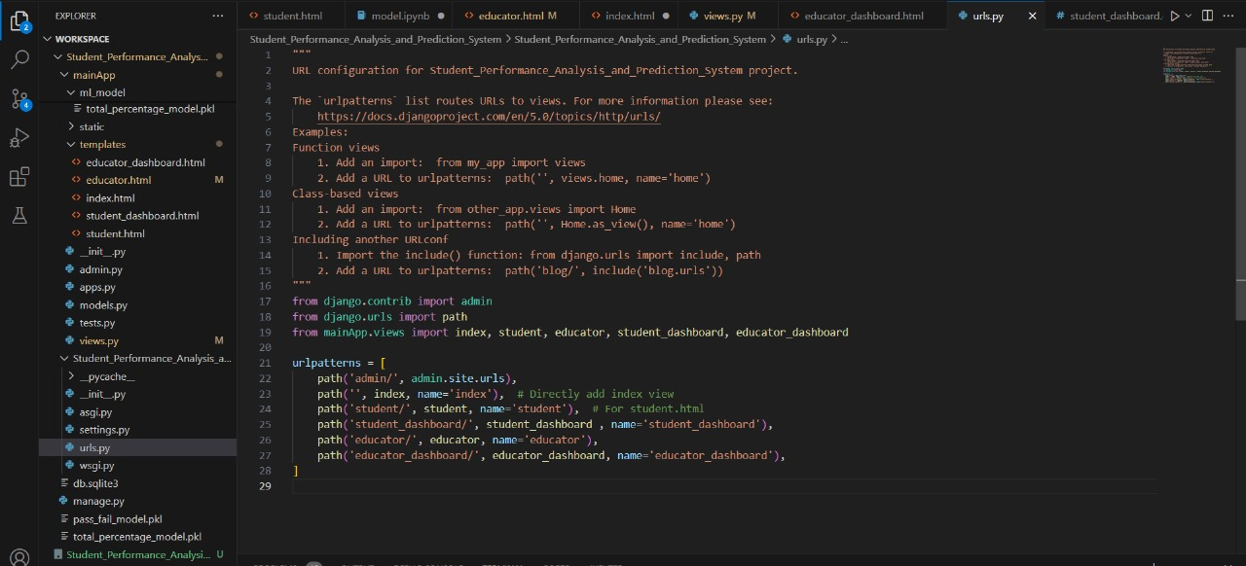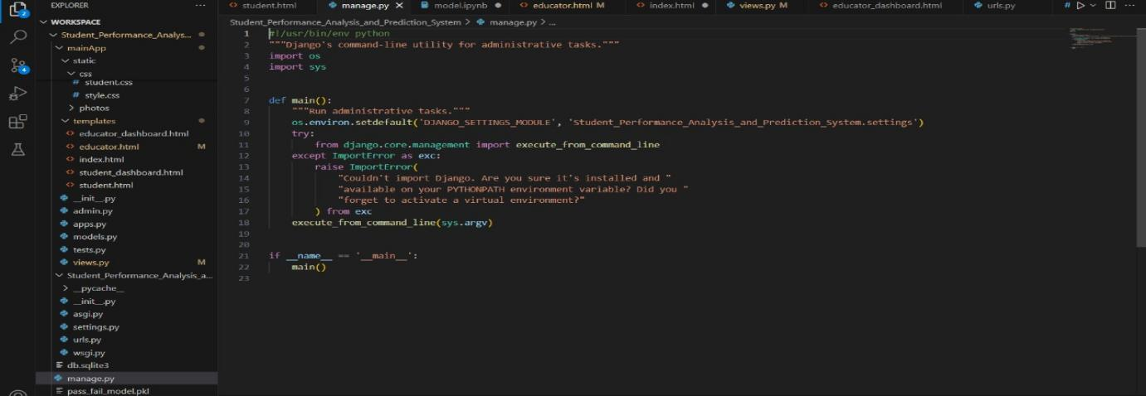

A research paper titled Text Classification Using Machine Learning Techniques [29] found several problems, when it comes to text classification. One that is of interest to this study is the problem of overrepresentation of the negative class; that is the situation where there are few instances of the category of interest in text categorization. This problem is an information retrieval type, which in turn causes errors in evaluating classifiers’ performance using the metric of Accuracy. Thus, the researchers suggest using Precision and Recall as a better measuring metric of performance. These measurements were used to assess selection methods. In this study, various ML algorithms were used for text classification and were compared and measured in terms of recall and precision.

# Results

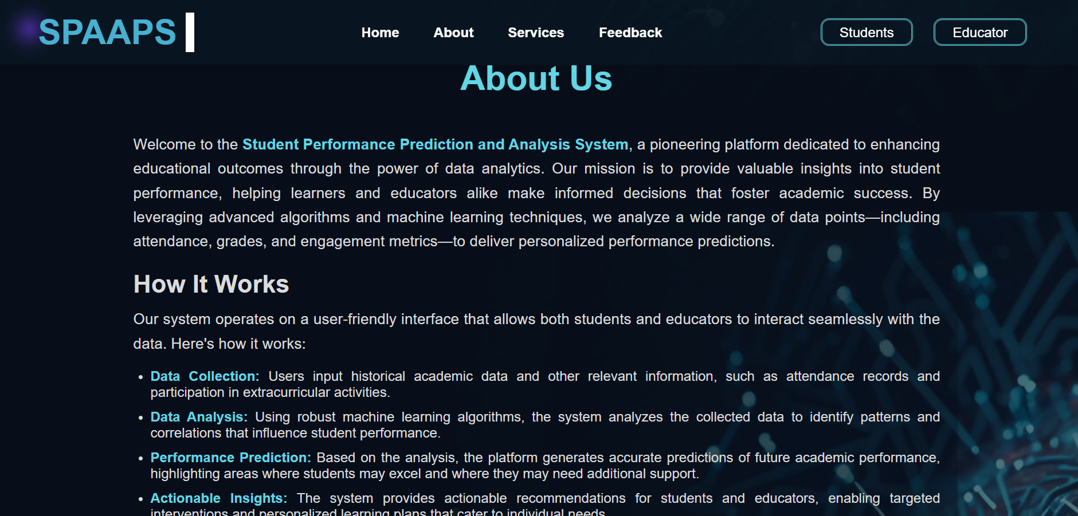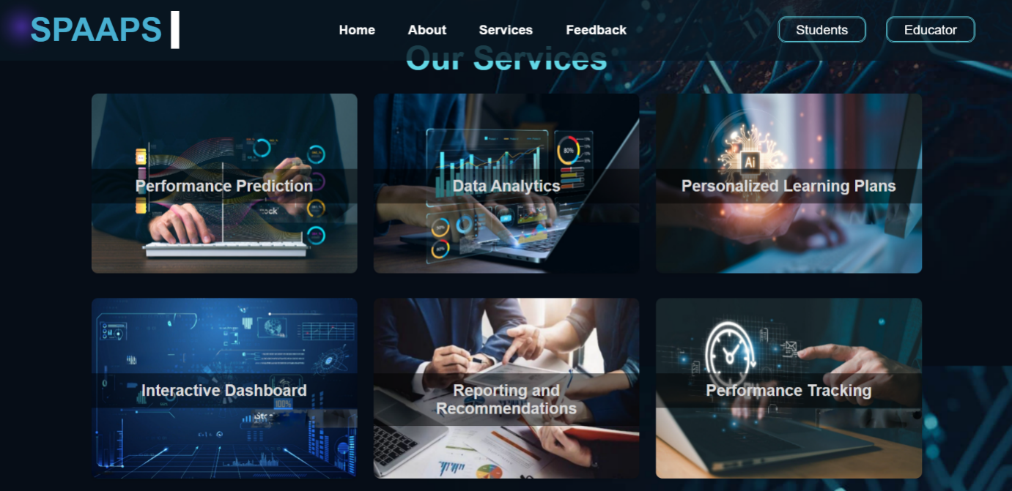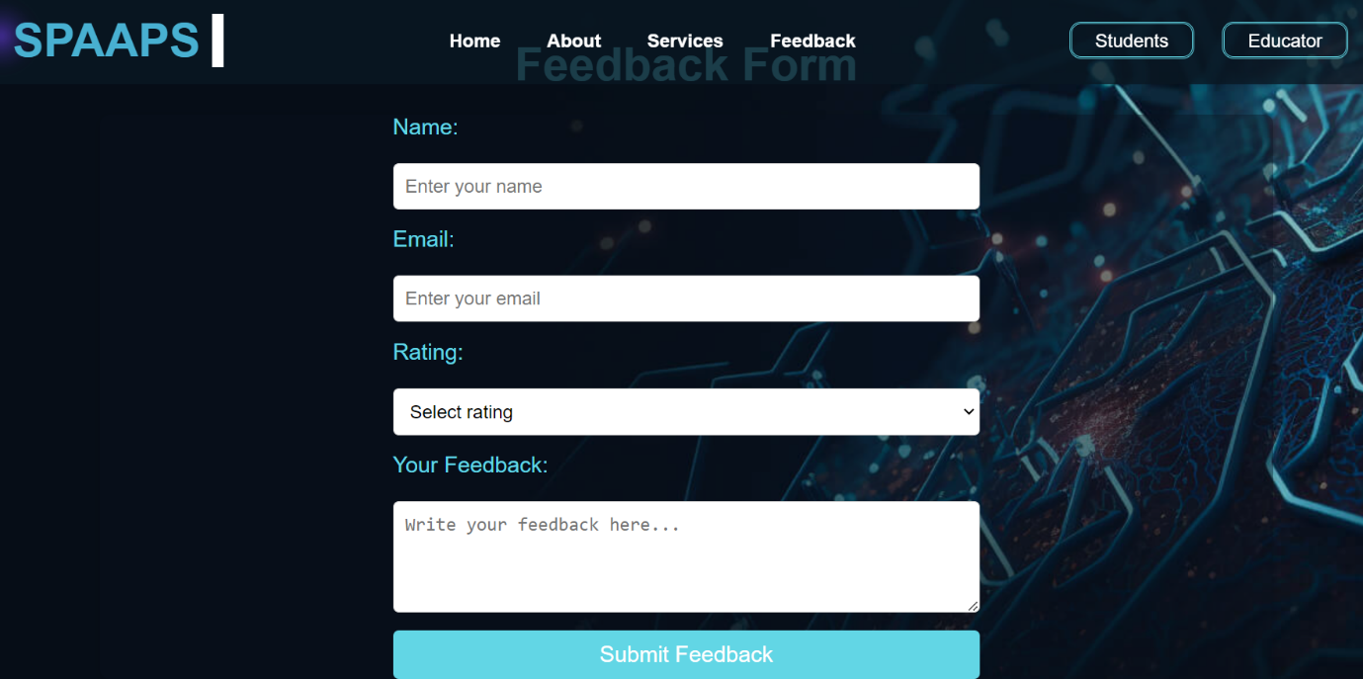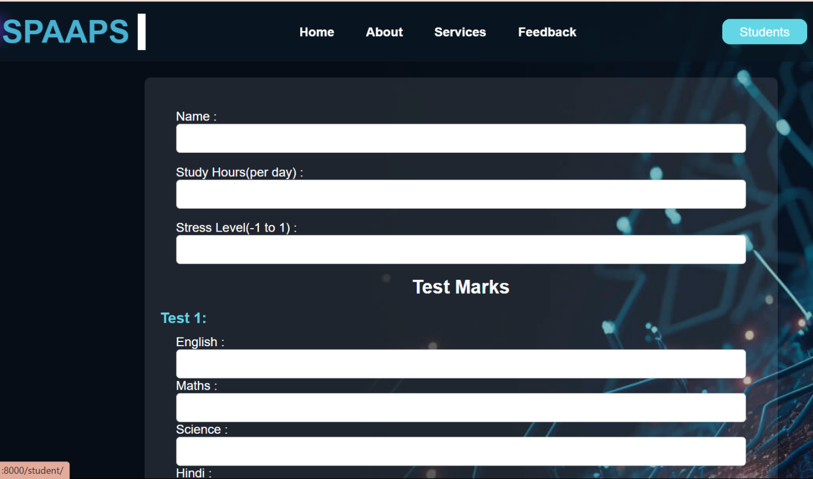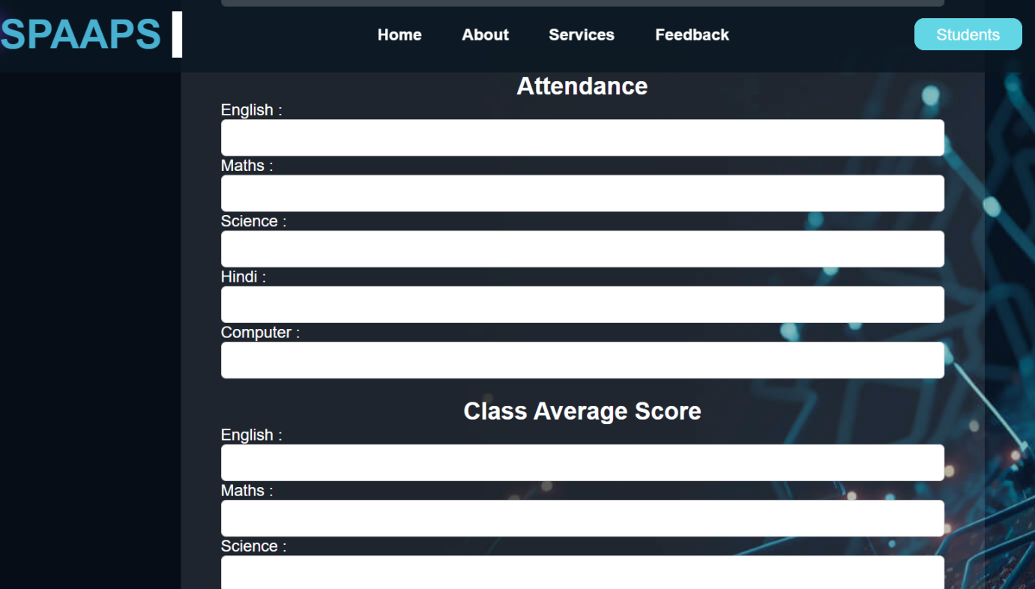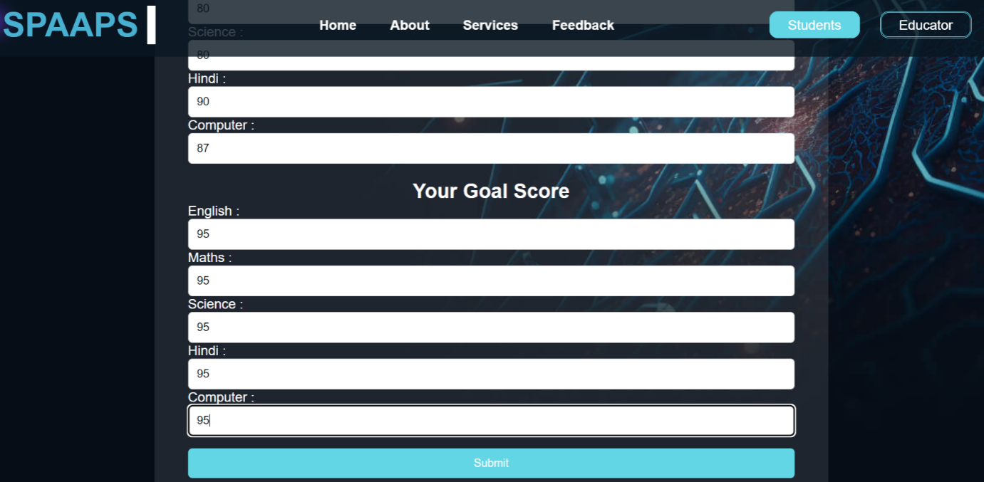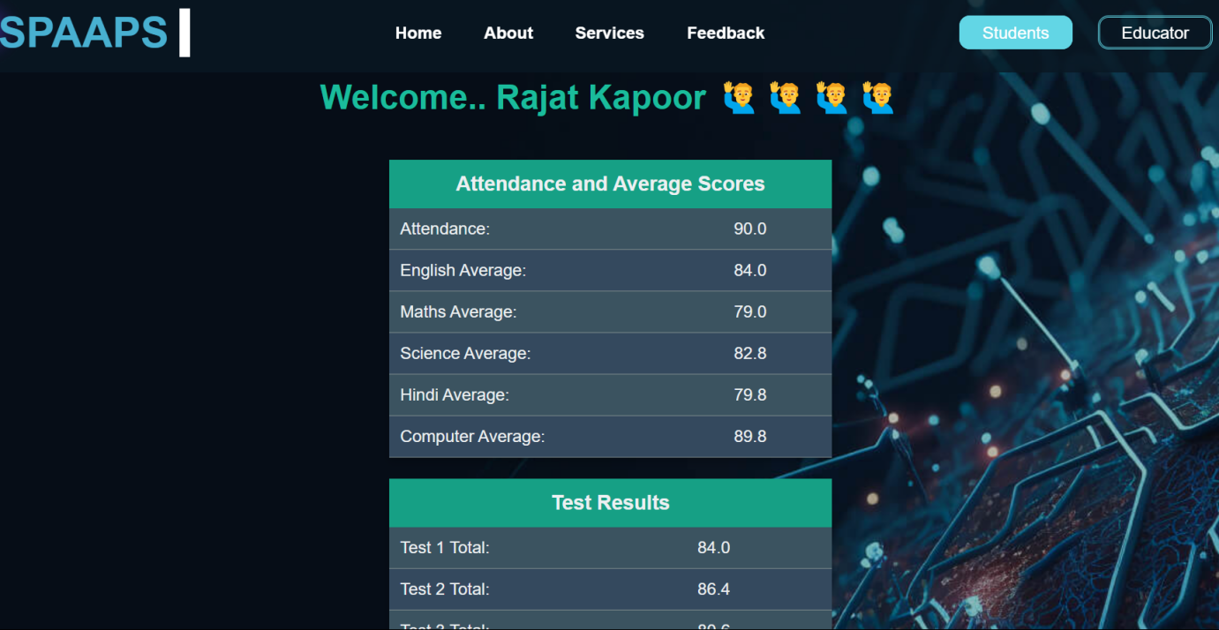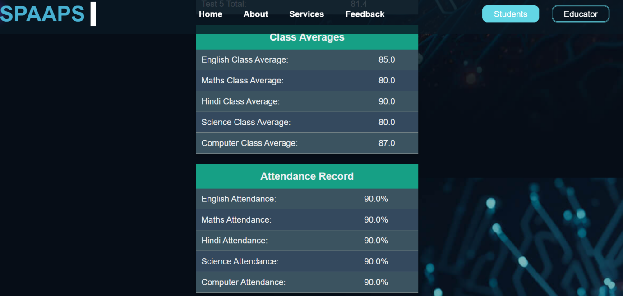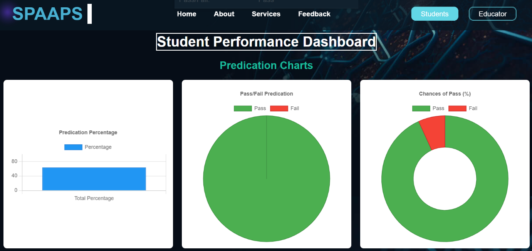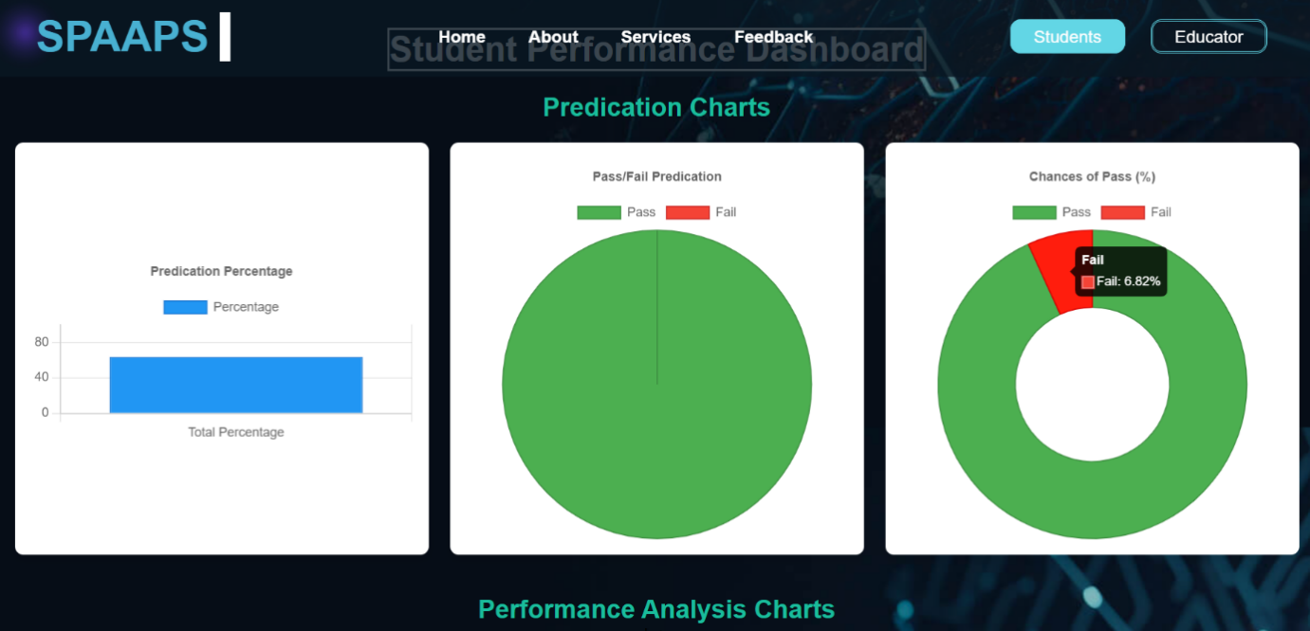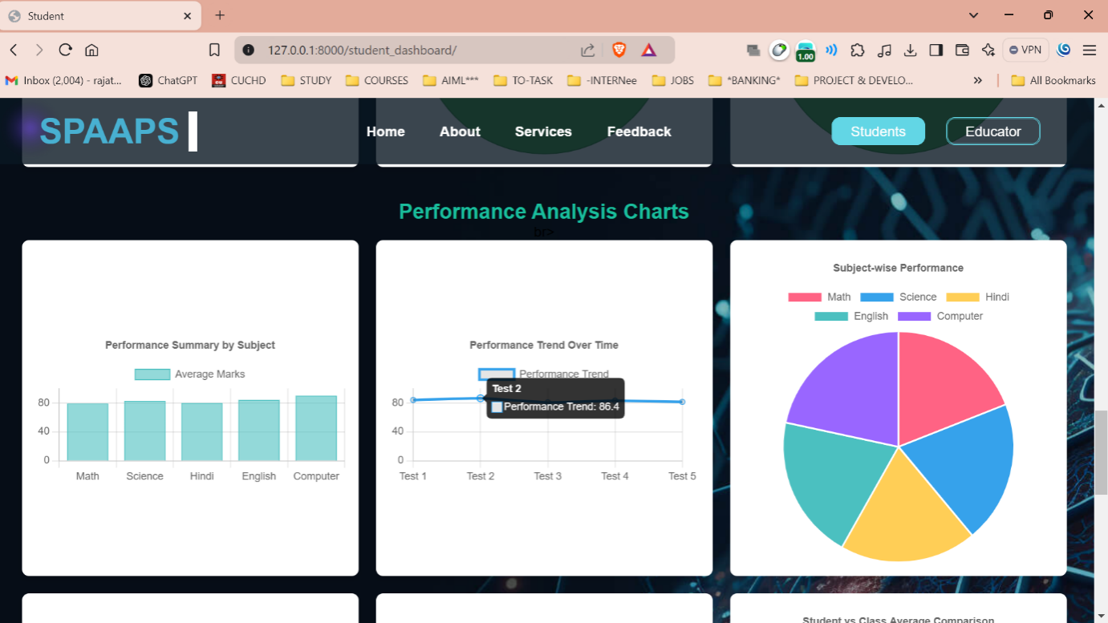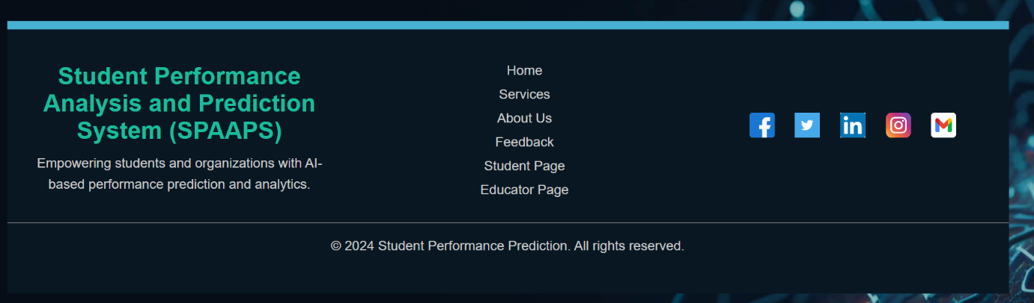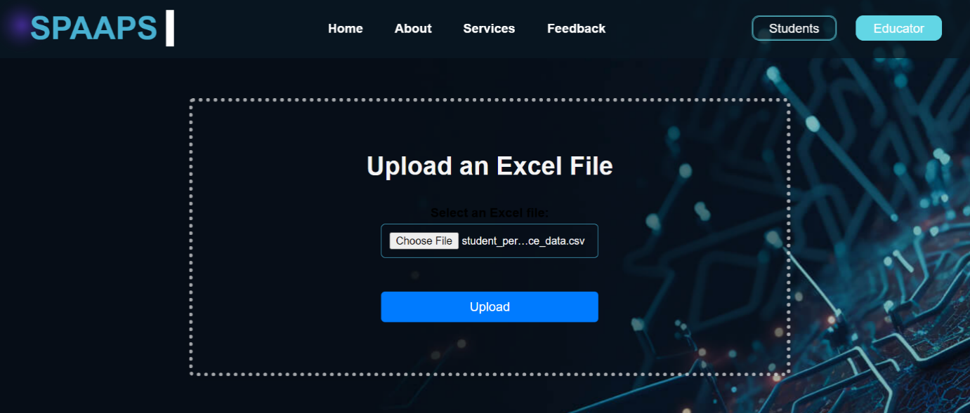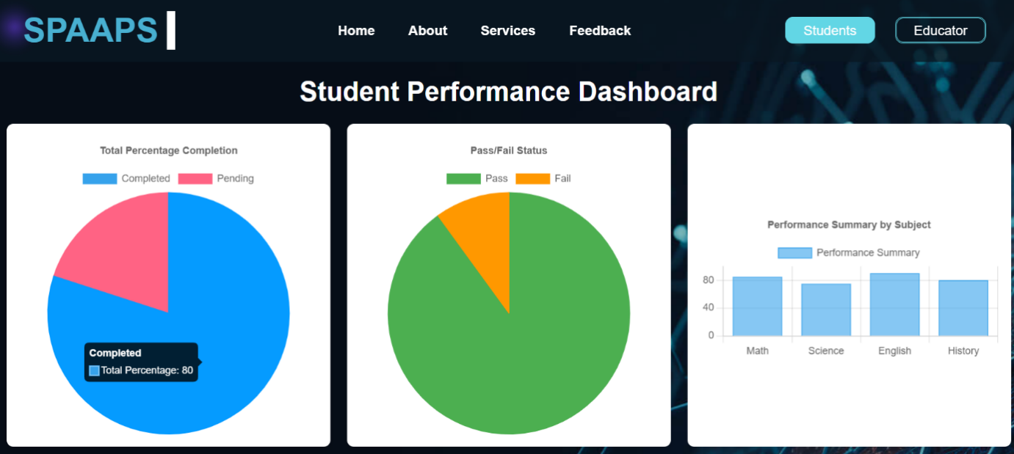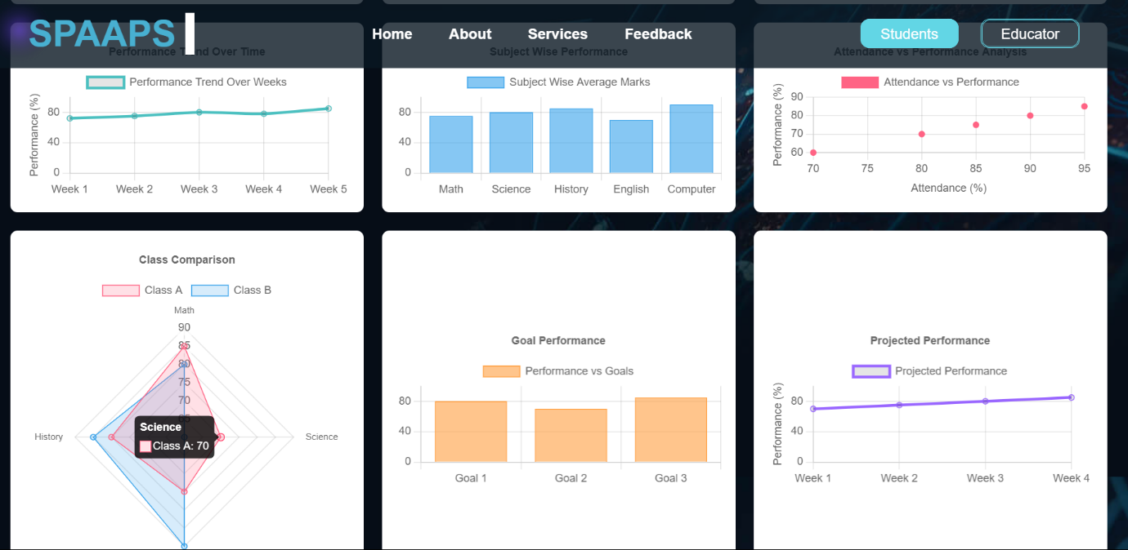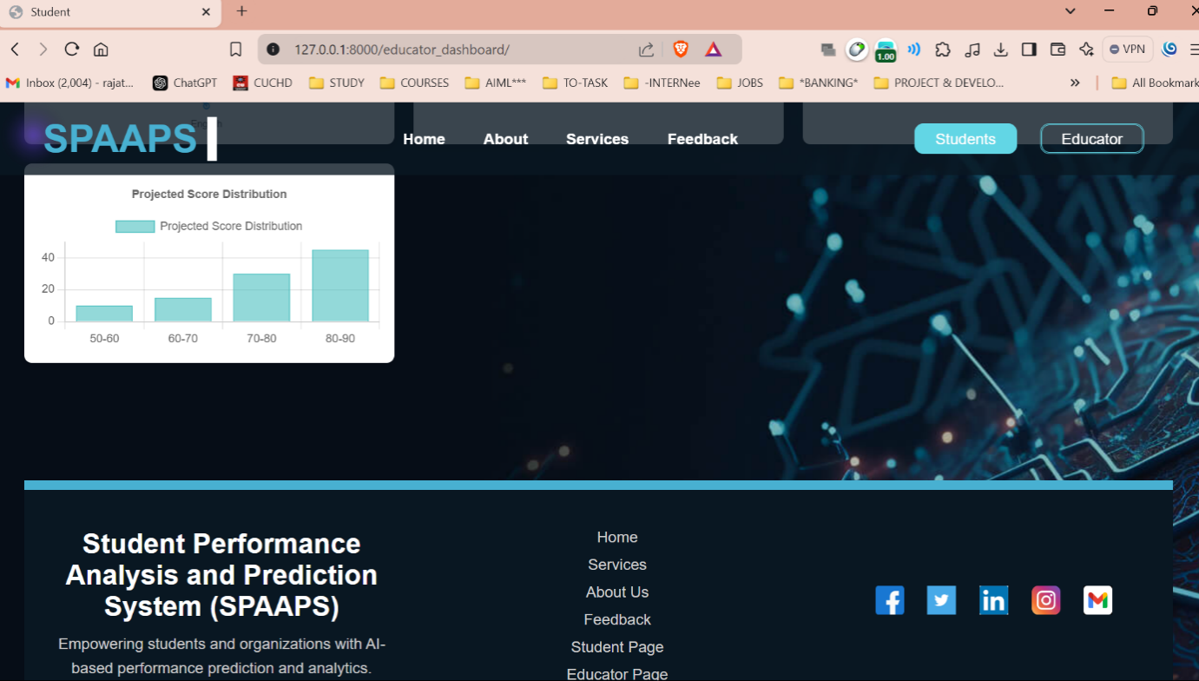

## 

# Discussion

This chapter discussed the possible reason why SVM performed better than ANN, as well as analyzed the method utilized (quantitative method) in the project.

## Analysis and discussion of results

The application was constructed ended up being a framework for binary student data to be inputted and outputted in the form of a prediction value for the likelihood of clearing a target course. The framework was constructed with the help of the TensorFlow framework as we as Keras API and TensorBoard, plus the dataset that was fetched from Ladok to train the ML models. The purpose of the application was twofold, one being technical in that it provided a scientific comparison study on how these ML model performed from these certain parameters in this certain environment (datatype/data size), the other one being to provide a method of predicting the likelihood of whether certain students would clear a given course, given their previous courses. As far as those end goals/purposes are concerned, the quota has been fulfilled sufficiently and correctly. The measurements were done TensorBoard and the TensorFlow framework itself as it was most convenient, and the framework provided all the functions necessary natively in one place to do so.

As to why SVM outperformed ANN, can be theorized because the number of parameters in an SVM increases linearly with the amount of the input. On the other hand, an ANN model does not. The SVM method is an excellent classification algorithm. It's a supervised learning method that's mostly used to divide data into categories. A collection of label data is used to train SVM. SVM has the benefit of being able to solve both classification and regression issues. However, it is believed that large data sets are not suited for the SVM method. When the data set contains additional noise, such as overlapping target classes, SVM does not perform well. The SVM will underperform if the number of features for each data point exceeds the number of training data samples.

## Project method discussion

The chosen method was a quantitative approach due to the nature of computer science and machine learning problems. They are inherently quantifiable and measurable. The method was broken down into small achievable and measurable milestones that could be worked on separately. The approach however was done in an ad hoc basis, as it wasn’t clear at the start which software tools and hardware to use, whether to use a cloud-based solution or a native one. All these approaches were figured out on the spot when the thesis needed it. The metrics that were measured (Accuracy, Precision, Recall, F1 Score, and Prediction) were chosen due to the abundance of resources surrounding them, the sheer volume of mathematical equations describing them, and due to measuring just the accuracy of a model doesn’t tell the whole story.

Precision is a quality indicator, whereas recall is a quantity indicator. A higher accuracy algorithm produces more relevant results than irrelevant ones, whereas a high recall algorithm delivers most relevant results (whether irrelevant ones are also returned). Accuracy is a parameter that sums up how well a model performs across all classes. When all classes are equally important, it is beneficial. The ratio between the number of right guesses and the total number of forecasts is used to compute it.

The first research question of the thesis was to figure out if ML algorithms were an appropriate way to find and identify these student patterns. To that extent, the study deems it to be an appropriate way. As the approach was when a pattern was generated, then the research question was fulfilled, the study was successful in that regard.

The second research question was to figure out how to implement the SVM and ANN models, and to figure out which model performed best in terms of accuracy, precision, recall, and f1 score on an open-source ML framework using student data from higher education credit data. To that end, and the verdict was that SVM outperformed ANN in all metrics listed, due to the number of parameters in an SVM increasing linearly with the amount of the input, as opposed to ANN not doing so in the same conditions. As for figuring out how to implement these models, that was successfully done with the TensorFlow framework.

The third research question was to ascertain how much data was needed to be able to draw conclusions for classifying the dataset. The thesis concluded that the size of the dataset (20 students) was sufficient, due to the model acquiring an overall higher trained accuracy than their respective baseline accuracy. The size of the dataset also decided the type of algorithms used, due to the nature of problem being a classification type of problem which the models were an appropriate solution for.

## Scientific discussion

Scientific knowledge is gained through the scientific method which can roughly be summed up to observing a certain phenomenon or asking a question regarding that phenomenon, researching what previous authors have written/said about that said phenomenon, synthesizing a hypothesis/question in regards to that phenomenon, conducting an (in the case of a quantitative study) empirical test, analyzing the produced data from the test, and finally synthesizing a conclusion based on the results from the test.

In the same vein, this study followed roughly the same path. In this case, a very specific question was asked regarding the performance of two ML algorithms pitted against each other and measured in terms of specific and measurable parameters. Consequently, the knowledge that was gained was also specific which is the following:

* SVM outperformed ANN regarding all the previously mentioned parameters.
* The theoretical knowledge gained is how SVM outperformed ANN under these certain conditions (binary data, and the size of the dataset).
* The factual knowledge is the accuracy of SVM of predicting student success in selected course.

In previous work, other similar studies were conducted in the field of predicting student performance. This thesis adds to that ever-expanding body of work, and what possibly extinguishes this thesis from the rest is the type of data used, the ML models trained and tested, and the small size of the dataset.

The limitation of this thesis is the size of the dataset, which limited the choices for the types of ML models that could be examined, as the size dictated that the type of data analysis would be that of the classification category, and not say the other types such as regression or clustering. Another limitation is just the scope of the study and what ML is capable of. Can it really predict human behavior?

In this study we got the results we got due to the inputs we chosen, but that doesn’t not necessarily guarantee that the results will hold for other types of input in other scenarios. This calls to question whether ML truly can predict all facets of human behavior/performance down to a tea, or whether the scientific paradigm still lacks the most fundamental knowledge of human conscience and decision making.

## Ethical and societal discussion

An aspect that came to mind as the thesis was being conducted is the impact of ML prediction on the freedom of individuals in a democratic society. How will these algorithms impact the quality of life of future generations in terms of the ability to participate in different academic fields/endeavors. Another aspect might be potential stressor on students to keep up with their performance which might lead to burnet and giving instead of persevering. Meritocracy could also gain even more legitimacy. Meritocracy is defined as the people who are in power are there because they “deserve” or worked hard for their positions and vice versa for the poor people. This paradigm has been under critique lately from authors such as Prof. Michael Sandel who wrote a book on the subject titled “The Tyranny of Merit: What’s Become of The Common Good?”

**7 Features:**

1. **Machine Learning-Based Predictions**:
   * **Accurate Performance Forecasting**: The system utilizes machine learning algorithms, specifically **Support Vector Machines (SVM)** and **Artificial Neural Networks (ANN)**, to predict student performance based on historical data.
   * **Enhanced Prediction Accuracy**: Both algorithms are optimized to deliver highly accurate predictions, improving the reliability of the results in forecasting student success or failure.
   * **Evaluation Metrics**: The system evaluates model performance using critical metrics such as **accuracy**, **precision**, **recall**, and **F1 score**, ensuring that the predictions align with actual outcomes.
2. **User-Friendly Interface (Django Web Framework)**:
   * **Interactive and Accessible**: The system is built with the **Django** web framework, providing an intuitive user interface for easy interaction with the model. Users can input student data and view predictions through a clean, straightforward dashboard.
   * **Seamless User Experience**: The interface allows users to input relevant student data (e.g., grades, attendance, etc.), with real-time prediction results being displayed in a user-friendly format. This helps users—whether administrators or educators—quickly make informed decisions.
3. **Real-Time Data Processing**:
   * **Instant Predictions**: The system processes student data in real-time, providing immediate predictions about student performance based on the trained models.
   * **Feedback Loop**: Users receive feedback on predicted student success or failure instantly, allowing them to take proactive actions such as providing additional support or resources.
4. **Scalability and Performance**:
   * **Handling Larger Datasets**: The system is capable of handling large datasets, ensuring that predictions remain accurate and consistent even as the number of students or data entries increases.
   * **Efficient Model Training**: The system is optimized to train models efficiently on datasets of various sizes, from small-scale datasets to larger educational datasets, ensuring scalability for different use cases.
5. **Accuracy and Reliability**:
   * **Model Precision**: The prediction models—especially the **SVM model**—are highly accurate, delivering precise performance predictions with minimal errors.
   * **Consistency in Predictions**: The system ensures that predictions are consistent and reliable, with high levels of accuracy across multiple datasets.
6. **Security and Data Integrity**:
   * **Data Protection**: While sensitive student data is not stored directly, the system implements secure data handling practices to ensure the integrity and privacy of the data.
   * **Secure Communication**: Future upgrades will include encrypted communication protocols to protect data as it moves between the user interface and the backend systems, ensuring secure transactions.
7. **Backup and Recovery**:
   * **System Recovery**: The system includes built-in recovery mechanisms to ensure it can recover from interruptions or crashes with minimal downtime.
   * **Data Backup**: Regular backups of critical student performance data and model parameters ensure that the system can recover quickly in the event of a failure, preventing data loss.

This student performance prediction system leverages machine learning to deliver real-time, accurate predictions, with a user-friendly interface and robust security measures, making it a reliable tool for educational institutions to forecast student success and intervene as needed.

**7 Future Scope:**

### ****1. Advanced Prediction Capabilities****

#### ****For Student Use:****

* **Personalized Performance Insights**: In the future, the system can provide personalized feedback and performance insights for each student based on their unique learning patterns, strengths, and weaknesses. This could include suggestions for improvement in specific subjects or areas where students need extra attention.
* **Behavioral and Emotional Indicators**: Incorporating data such as behavioral indicators (e.g., student engagement, class participation, etc.) or emotional factors (e.g., mood or mental health status) could improve prediction accuracy and provide more holistic performance insights.

#### ****For Educator Use:****

* **Subject-Specific Predictions**: Educators can benefit from more granular predictions that focus on individual subjects or skills. For example, the system could predict not only overall student performance but also success in specific courses or academic areas (e.g., mathematics, science, etc.).
* **Dropout Prediction**: The system can incorporate dropout prediction algorithms to identify students at risk of leaving the course or program, enabling timely interventions.

### ****2. Enhanced Accuracy and Speed with Model Optimization****

#### ****For Student Use:****

* **Real-Time Predictions**: The system could be optimized to provide real-time predictions as new student data is input, enabling students to track their performance over time and receive up-to-date feedback without delays.
* **Edge Device Compatibility**: A mobile app or lightweight version of the prediction system could be developed to allow students to check their predicted performance and insights on the go, using their smartphones or tablets.

#### ****For Educator Use:****

* **Data Efficiency and Scalability**: As the number of students grows, the system must scale efficiently. Using techniques like model pruning, quantization, and distributed training can help the system handle larger datasets from numerous students without compromising on accuracy or speed.
* **Model Retraining with New Data**: Continuous improvement by retraining the models on newly collected data (e.g., after each academic year or semester) will help maintain the relevance and accuracy of the predictions as student behaviors and learning patterns evolve.

### ****3. Multi-User Integration and Collaboration****

#### ****For Student Use:****

* **Collaborative Learning**: The system could integrate social features, such as group performance tracking or collaborative learning insights, where students can see how their performance compares to peers and engage in study groups based on similar weaknesses or strengths.

#### ****For Educator Use:****

* **Faculty Dashboard**: Educators and administrators could benefit from a centralized dashboard that aggregates data from multiple students or classes. The system could allow for comparisons between different student groups or performance trends over time.
* **Collaboration Tools for Educators**: The platform could integrate features that allow educators to collaborate, such as sharing best practices based on the performance of students in similar academic settings or exchanging predictions and intervention strategies.

### ****4. Real-Time Data Analytics and Reporting****

#### ****For Student Use:****

* **Predictive Feedback System**: Students could receive real-time alerts or notifications based on their predicted performance. For example, if a student’s performance is likely to decline, the system could send proactive reminders to review study materials or reach out for additional support.
* **Progress Visualization**: Future iterations could include more advanced data visualization techniques, such as interactive charts or graphs that allow students to track their progress throughout the academic term.

#### ****For Educator Use:****

* **Advanced Analytics Dashboard**: Educators could benefit from an advanced analytics dashboard, which would display trends, subject-specific performance breakdowns, and overall academic health of their class in real time. This would enable better decision-making for interventions and course adjustments.
* **Automated Reporting**: The system could automate the generation of performance reports, highlighting areas where students need additional resources or support. Educators could use this data to design targeted interventions for struggling students.

### ****5. Integration with Other Educational Tools and Systems****

#### ****For Student Use:****

* **Integration with Learning Management Systems (LMS)**: The prediction system could be integrated with existing LMS platforms (like Moodle, Blackboard, or Google Classroom), allowing students to view their predicted performance alongside their actual grades, attendance, and other academic data in one place.
* **Personalized Learning Resources**: Based on prediction results, the system could recommend learning resources, such as videos, books, or practice exercises, tailored to the student’s needs and areas of improvement.

#### ****For Educator Use:****

* **Integrating with Institutional Systems**: The system can be integrated with institutional databases to retrieve broader datasets, such as historical student performance across multiple years or across different courses, to provide better predictions and insights.
* **AI-Driven Teaching Strategies**: By combining predictions with AI-driven learning analytics, educators could receive suggestions for personalized teaching strategies, helping them to tailor their courses to better meet the needs of individual students.

### ****6. Ethical Considerations and Data Privacy****

#### ****For Student Use:****

* **Data Privacy**: Ensuring robust data privacy and security protocols is critical for student data. Future versions of the system should use encryption and anonymization techniques to safeguard student information.
* **Bias Mitigation**: Ongoing efforts to reduce bias in the prediction models will be necessary to ensure that all students, regardless of their background, are treated fairly by the system. This could include regularly auditing the models for fairness and updating them as required.

#### ****For Educator Use:****

* **Transparency and Explainability**: Future versions could incorporate explainable AI (XAI) techniques that help educators understand how predictions are made, ensuring that they can trust and interpret the results better for their students' benefit.

**7. Limitation:**

1. **Accuracy and Data Quality:**
   * **Incomplete or Inaccurate Data:** The system heavily relies on historical student performance data for making predictions. If the data used for training the model is incomplete, inaccurate, or biased, the predictions may not be reliable or reflective of the actual student capabilities.
   * **Data Skewness and Imbalances:** In case of skewed datasets, where certain classes (like high performers or low performers) are underrepresented, the model might give biased predictions. This can lead to inaccurate performance predictions for specific student groups.
2. **Generalization and Adaptability:**
   * **Limited Generalization Across Schools:** The system might be trained on data from one institution or a small subset of students, which may not generalize well to other schools or educational systems. Changes in curriculum or teaching methods can significantly affect performance predictions, necessitating retraining on new data.
   * **Adaptability to New Student Profiles:** If the system encounters new student profiles with different learning behaviors, it may struggle to adapt without the integration of custom-trained models or additional data from diverse groups of students.
3. **Model Complexity and Interpretability:**
   * **Complexity of Predictions:** While machine learning models (such as decision trees, SVM, etc.) are often used for prediction, they may lack transparency in their decision-making process. Students and educators might find it difficult to understand why a specific prediction was made, limiting the trust and usability of the system.
   * **Lack of Interpretability for Non-Technical Users:** Educators and students who are not familiar with machine learning might struggle to interpret or trust the model’s predictions, making it essential to have intuitive visualizations or simplified explanations.
4. **Real-Time Performance:**
   * **Slow Predictions for Large Datasets:** If the system is processing a large number of students (e.g., an entire school), the time taken for prediction might increase. This can lead to delays in generating timely insights, which are crucial for decision-making, especially when frequent updates are needed.
   * **Latency in Personalized Predictions:** For real-time predictions, such as during live assessments or in-class performance tracking, the system might experience delays, particularly when integrated into classroom settings with live feedback loops.
5. **Overfitting and Over-Reliance on Historical Data:**
   * **Risk of Overfitting:** If the model is too complex or trained on a limited dataset, it may overfit to the historical data, which means it may perform poorly on new or unseen data. Overfitting can make the system unreliable in predicting future performance, especially when students' learning styles evolve over time.
   * **Over-Reliance on Past Data:** The system might fail to account for sudden changes in student behavior, teaching methods, or external factors (e.g., personal issues, current events), which could lead to mispredictions if not regularly updated.
6. **Privacy and Ethical Concerns:**
   * **Data Privacy Issues:** The prediction system relies on sensitive data, such as student grades, attendance, and personal details. Without robust data protection measures, there could be risks of unauthorized access or misuse of this data. Privacy concerns might arise if students or parents are unaware of how their data is being used.
   * **Ethical Considerations in Prediction:** Students and educators may feel uncomfortable relying on algorithmic predictions for decisions about a student's future. Predictions may impact student morale and self-esteem if not communicated correctly, or if students feel they are being unfairly judged by the system.
7. **Customization and Flexibility:**
   * **Limited Customization for Individual Learning Styles:** While the system can predict general performance trends, it might not always account for the unique learning needs of each student, such as those with learning disabilities or those who require a different approach to learning. This limits the model’s ability to provide personalized support.
   * **Rigid Framework for Educators:** The system might not fully cater to the varied requirements of different educators. For example, some educators might prefer predictive models based on behavior or participation in class, which might not be effectively captured by the system’s current design.

**8 . Conclusion: -**

**Conclusion for the Student Performance Prediction Project:**

The primary objective of this study was to evaluate and compare the performance of different machine learning (ML) algorithms for predicting student performance, based on various evaluation metrics such as accuracy, precision, recall, and F1 score. Additionally, the goal was to develop a robust framework for predicting student performance and assessing its validity.

The results of this study demonstrate that ML algorithms, particularly **Support Vector Machines (SVM)** and **Artificial Neural Networks (ANN)**, are highly effective tools for predicting student performance. These algorithms showed improvements in prediction accuracy compared to baseline models, thereby validating their effectiveness for this task. **SVM** emerged as the top performer, achieving superior results in accuracy, precision, recall, and F1 score, largely due to its ability to effectively handle complex, high-dimensional data and linearly scale with increasing input features. This was contrasted with the **ANN**, which showed a less consistent performance due to its structure and hyperparameter sensitivity.

The research was divided into three key questions:

1. **Are ML algorithms appropriate for predicting student performance patterns?**  
   The study clearly confirms that ML algorithms are highly suitable for identifying patterns in student performance data. The prediction results accurately matched the “success” values in the dataset, demonstrating the algorithm's ability to capture meaningful patterns in the data.
2. **Which ML model performs best in terms of accuracy, precision, recall, and F1 score when applied to student data?**  
   Through the implementation of **SVM** and **ANN** using the **TensorFlow** framework (Keras API), the study found that SVM outperformed ANN in all the listed parameters, confirming its superior suitability for this specific problem.
3. **How much data is needed to achieve valid predictions?**  
   The amount of data required is crucial for achieving an accurate and reliable model. It was found that having enough data to ensure the trained models' accuracy exceeded the baseline was necessary for meaningful predictions. While the study did not fix an exact number, it is recommended that datasets with at least a few thousand samples should suffice to produce reliable results for similar tasks.

The scientific knowledge gained from this study can be summarized in three key points:

1. **Legitimacy of ML Algorithms for Student Performance Prediction**: The study affirms that ML algorithms are highly appropriate for predicting student performance based on data from educational datasets such as Ladok.
2. **SVM and ANN Performance**: Insights were gained into how both **SVM** and **ANN** react under these conditions, with **SVM** emerging as the most reliable model for this type of educational data.
3. **Data Sufficiency**: A robust method for determining the sufficient size of datasets was proposed, which could guide future research in similar educational prediction tasks.

Overall, this project contributes valuable insights into the **binary classification of smaller datasets** (e.g., <100,000 samples) using machine learning. The findings of this study provide an important foundation for future research and applications in the field of student performance prediction, with the potential for integration into real-world educational systems to support data-driven decision-making.

**9. References:**

1. OECD Publishing. (2019). *OECD (2019), Education at a Glance*

*2019* [Ebook] (p. 2). Paris. Retrieved from

[https://www.oecd.org/education/education-at-a glance/EAG2019\_CN\_SWE.pdf](https://www.oecd.org/education/education-at-a%20glance/EAG2019_CN_SWE.pdf)

1. BANSAL, S., 2021. What is Classification Algorithm in Machine Learning? With Examples. [Blog] *Analytix Labs*, Available at: <https://www.analytixlabs.co.in/blog/classification-in-machinelearning/> [Accessed 1 September 2021].
2. M. Weiss, S. and Kapouleas, I., 2021. *An Empirical Comparison of Pattern recognition, Neural Nets, and Machine Learning Classification*

*Methods*. [ebook] New Brunswick, New Jersey: Rutgers University Press, p.1. Available at:

<https://citeseerx.ist.psu.edu/viewdoc/download?doi=10.1.1.81.9 576&rep=rep1&type=pdf> [Accessed 1 September 2021].

1. M. Education, "Overview - Dropout Reduction: Prevention, Intervention, and Recovery", *Doe.mass.edu*, 2009. [Online].

Available:

https://www.doe.mass.edu/dropout/overview.html?section=cons equences. [Accessed: 16- Jun- 2022].

1. A. Mishra, "Metrics to Evaluate your Machine Learning Algorithm", *Medium*, 2018. [Online]. Available:

https://towardsdatascience.com/metrics-to-evaluate-yourmachine-learning-algorithm-f10ba6e38234. [Accessed: 16- Jun- 2022].

1. "Transformer (machine learning model) - Wikipedia", *En.wikipedia.org*. [Online]. Available: https://en.wikipedia.org/wiki/Transformer\_(machine\_learning\_ model)#cite\_note-:0-1. [Accessed: 16- Jun- 2022].
2. S. Brown, "Machine learning, explained | MIT Sloan", *MIT Sloan*, 2021. [Online]. Available: https://mitsloan.mit.edu/ideas-madeto-matter/machine-learning-

explained#:~:text=Machine%20learning%20is%20a%20subfield% 20of%20artificial%20intelligence%2C%20which%20is,to%20how %20humans%20solve%20problems. [Accessed: 16- Jun- 2022]. [8] J. Delua, "Supervised vs. Unsupervised Learning: What’s the Difference?", *Ibm.com*, 2021. [Online]. Available: https://www.ibm.com/cloud/blog/supervised-vs-unsupervisedlearning. [Accessed: 16- Jun- 2022].

1. M. Chicago, "An introduction to machine learning", *Cfss.uchicago.edu*. [Online]. Available: https://cfss.uchicago.edu/slides/machine-learning/#10. [Accessed: 16- Jun- 2022].
2. R. Merritt, "What Is a Transformer Model?", *NVIDIA Blog*,
   1. [Online]. Available:

https://blogs.nvidia.com/blog/2022/03/25/what-is-a-transformermodel/. [Accessed: 16- Jun- 2022].

1. R. Brown, "What is Text Classification in Machine Learning?", *Medium*, 2020. [Online]. Available:

https://becominghuman.ai/what-is-text-classification-inmachine-learning-46f0ae73a6d0. [Accessed: 16- Jun- 2022].

1. A. Verma, "Application of BERT : Binary Text

Classification", *OpenGenus IQ: Computing Expertise & Legacy*. [Online]. Available: https://iq.opengenus.org/binary-textclassification-

bert/#:~:text=Binary%20text%20classification%20is%20supervise d,our%20binary%20classifier%20on%20it. [Accessed: 16- Jun- 2022].

1. S. S., "Neural Networks: All YOU Need to Know", *Medium*, 2018. [Online]. Available: https://towardsdatascience.com/nnsaynk-c34efe37f15a. [Accessed: 16- Jun- 2022].
2. "Support Vector Machine Algorithm -

GeeksforGeeks", *GeeksforGeeks*, 2021. [Online]. Available:

https://www.geeksforgeeks.org/support-vector-machinealgorithm/. [Accessed: 16- Jun- 2022].

1. T. Yiu, "Understanding Random Forest", *Medium*, 2019.

[Online]. Available:

https://towardsdatascience.com/understanding-random-forest58381e0602d2. [Accessed: 16- Jun- 2022].

1. B. Agarwal and N. Mittal, "Text Classification Using Machine Learning Methods-A Survey", *Advances in Intelligent Systems and Computing*, pp. 701-709, 2014. Available: 10.1007/97881-322-1602-5\_75 [Accessed 16 June 2022].
2. K. Kowsari, K. Jafari Meimandi, M. Heidarysafa, S. Mendu, L. Barnes and D. Brown, "Text Classification Algorithms: A Survey", *Information*, vol. 10, no. 4, p. 150, 2019. Available: 10.3390/info10040150.
3. M. Ahmad, A. Asad and A. Mohammed, "A Machine

Learning Based Approach for Student Performance Evaluation in Educational Data Mining", *2021 International Mobile, Intelligent, and Ubiquitous Computing Conference (MIUCC)*, 2021. Available: 10.1109/miucc52538.2021.9447602 [Accessed 16 June 2022].

1. T. Padilha and R. Catrambone, "USE OF THE TENSORFLOW FRAMEWORK TO SUPPORT EDUCATIONAL PROBLEMS: A SYSTEMATIC MAPPING", *International*

*Conference on Education*, 2021. Available:

10.17501/24246700.2021.7133 [Accessed 16 June 2022].

1. J. Xu, K. Moon and M. van der Schaar, "A Machine Learning Approach for Tracking and Predicting Student Performance in Degree Programs", *IEEE Journal of Selected Topics in Signal Processing*, vol. 11, no. 5, pp. 742-753, 2017. Available: 10.1109/jstsp.2017.2692560 [Accessed 16 June 2022].
2. Classification: Accuracy | Machine Learning Crash Course.

(2021). Retrieved 2 September 2021, from

[https://developers.google.com/machine-learning/crashcourse/classification/accuracy](https://developers.google.com/machine-learning/crash-course/classification/accuracy)

1. Classification: Precision and Recall | Machine Learning Crash Course. (2021). Retrieved 2 September 2021, from [https://developers.google.com/machine-learning/crashcourse/classification/precision-and-recall](https://developers.google.com/machine-learning/crash-course/classification/precision-and-recall)
2. J. Brownlee, "How to Calculate Precision, Recall, and FMeasure for Imbalanced Classification", *Machine Learning Mastery*,

2020. [Online]. Available:

https://machinelearningmastery.com/precision-recall-and-fmeasure-for-imbalanced-

classification/#:~:text=For%20example%2C%20a%20perfect%20pr ecision,(2%20\*%201.0)%20%2F%202.0. [Accessed: 16- Jun- 2022].

1. J. Brownlee, "How Much Training Data is Required for Machine Learning?", *Machine Learning Mastery*, 2017. [Online].

Available: https://machinelearningmastery.com/much-trainingdata-required-machine-learning/. [Accessed: 16- Jun- 2022].

1. "ML Studio (classic): Machine Learning Scoring - Azure", *Docs.microsoft.com*, 2020. [Online]. Available:

https://docs.microsoft.com/en-us/previousversions/azure/machine-learning/studio-modulereference/machine-learning-score. [Accessed: 16- Jun- 2022].

1. *GUIDELINE FOR MASTER’S THESIS EVALUATION*. Espoo, Finland: Aalto University School of Electrical Engineering, 2012, pp. 1-3.
2. "7 Stages of Machine Learning — A Framework", *Medium*,
   1. [Online]. Available:

https://medium.com/@datadrivenscience/7-stages-of-machinelearning-a-framework-33d39065e2c9. [Accessed: 16- Jun- 2022].

1. D. Gray, "What Makes Successful Frameworks Rise Above the Rest", *MIT Sloan Management Review*, 2021. [Online]. Available:

https://sloanreview.mit.edu/article/what-makes-successfulframeworks-rise-above-the-rest/. [Accessed: 16- Jun- 2022].

1. Ikonomakis, M., Kotsiantis, S. and Tampakas, V., 2021. *Text Classification Using Machine Learning Techniques*. [ebook] Patra,

Greece: The University of Patras, p.1. Available at: <https://citeseerx.ist.psu.edu/viewdoc/download?doi=10.1.1.95.9 153&rep=rep1&type=pdf> [Accessed 1 September 2021].

#### ****10 Steps for Generating the Plagiarism Report:****

1. **Prepare Your Document:**
   * Ensure that your project report or documentation is in a readable format such as **.docx**, **.pdf**, or **.txt**. This will make it compatible with various plagiarism checking tools. The document should include all sections like introduction, methodology, results, and conclusion, and should reflect the details of your **Student Performance Prediction System** project, including any datasets, algorithms, and models used.
2. **Choose a Plagiarism Checker:** Below are some tools you can use to check for plagiarism in your project document:
   * **Small SEO Tools Plagiarism Checker:**
     + Upload your project document to **Small SEO Tools** for a plagiarism check. This tool scans the document against a large database of web sources and academic publications. It will flag any sections that match with content already available online.
     + **Link:** Small SEO Tools Plagiarism Checker
   * **Check-Plagiarism Plagiarism Checker:**
     + This tool compares your document to a wide range of sources and highlights copied content. It provides a detailed report showing percentage similarity and specific matches to external sources.
     + **Link:** Check-Plagiarism Plagiarism Checker
   * **Quetext Plagiarism Checker:**
     + Quetext is another popular plagiarism detection tool. The free version allows basic checks, while the pro version offers more detailed results. This tool checks the text against numerous online databases to detect potential plagiarism.
     + **Link:** [Quetext Plagiarism Checker](https://www.quetext.com/" \t "_new)
3. **Analyze the Results:**
   * After uploading your document, the plagiarism checker will scan it and generate a **plagiarism report**.
   * The report will typically include a **percentage of similarity**, highlighting sections that match content from external sources. These sections will be flagged for your review.
   * **Review the flagged sections carefully** to ensure they are appropriately paraphrased or cited. If any content is inadvertently copied or improperly referenced, it should be modified or reworded to ensure originality.
4. **Correct and Recheck:**
   * If any plagiarism is detected, make the necessary adjustments:
     + **Rephrase the copied content**: Reword sections that were flagged as similar to other sources, ensuring the text is unique.
     + **Cite the source properly**: Any borrowed content should be referenced correctly in your project, with citations listed in the references section.
   * Once corrections are made, upload the updated version to the plagiarism checker to confirm that it is now free from plagiarism.

#### ****11. Additional Tips:****

* **Citations and Paraphrasing:**
  + Ensure that any content taken directly from research papers, textbooks, or online resources is properly cited. This includes using in-text citations and a full references section in your project.
  + For non-direct content, ensure the text is paraphrased in your own words to avoid plagiarism.
* **Use Turnitin:**
  + If your institution has access to **Turnitin**, it’s one of the most reliable plagiarism-checking tools. You can use Turnitin for a more in-depth analysis and to ensure that your work is free of any unintentional plagiarism.
* **Refrain from Excessive Quoting:**
  + Overuse of direct quotes can be a sign of poor paraphrasing and may increase the plagiarism percentage. Strive to paraphrase content where possible.

**Tools Links:**

* **Small SEO Tools:** Plagiarism Checker
* **Check-Plagiarism:** Plagiarism Checker
* **Quetext:** [Plagiarism Checker](https://www.quetext.com/" \t "_new)

These tools will give you a clear understanding of how original your **Student Performance Prediction System** project is, especially after integrating data sources, machine learning algorithms, and predictive models.

#### ****12. Appendix A: Source Code****

Avoid using actual program code in the report. Instead, provide a link here to a repository or someplace where the code can be downloaded. But remember that you must mention this appendix somewhere in the report e.g. For the complete source code, see Appendix A.

